

**SCHOOL OF INFORMATICS & IT**

**DIPLOMA IN APPLIED ARTIFICIAL INTELLIGENCE**

**CLOUD TECHNOLOGIES FOR AI (CAI2C09)**

**AY2024/2025 APRIL SEMESTER**

**Project Report**

Student Name (Matric Number) : Soh Le E Celest (2301028C)

Class Group : PC02

Tutor : Emile Sabastian

Submission Date : 12 August 2024

Contents

Introduction of website 3

Development of AWS Rekognition 9

Development of Simple Notification Service 14

Development of Amazon Cognito 18

Deployment process 21

Setup guide 22

Conclusion 50

References 50

# Introduction of website

Problem Statement

Many people go missing for reasons such as dementia, running away from home, mental ailments, and abduction. Authorities may struggle to find missing people as they must search vast areas as well as collect and observe surveillance imagery that may end up useless, making the search challenging and time-consuming. The long delays caused also places the missing person’s well-being at risk if they are in a vulnerable situation, like trafficking. Additionally, loved ones suffer prolonged emotional distress without closure. Therefore, a time-efficient and comprehensive solution should be produced to improve the search process.

Website

Find Missing Faces is a solution to the above problem statement that utilises facial recognition technology and gathers public contribution to expedite finding missing people, as well as make accessible to loved ones any updates to the status of the search.

Loved ones may submit a profile of the missing person, including a portrait and close contact, while general users may submit images for AWS Rekognition’s model to detect faces in the image then compare each face to the stored portraits of missing people’s profiles. The top 3 matches are displayed, and contacts of each person may be contacted up to the user’s discretion.

URL: <http://find-missing-faces-website.s3-website-us-east-1.amazonaws.com/>

Demonstration

Link to video demonstration of website: <https://youtu.be/qZtPXH2kQ1U>

Screenshots

Figure 1. Authentication Page - Initial page for unregistered/logged out users.

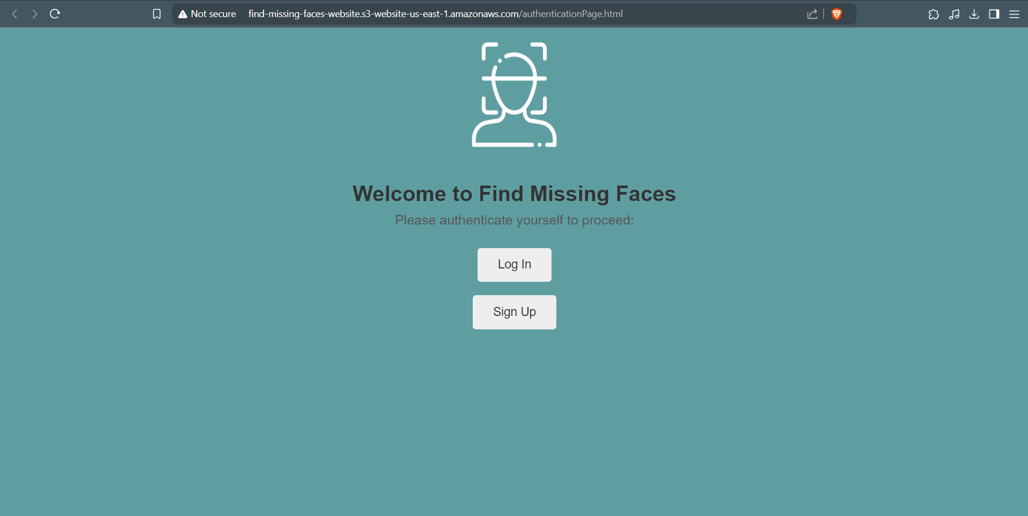

Figure 2. Sign Up page - For unregistered users.

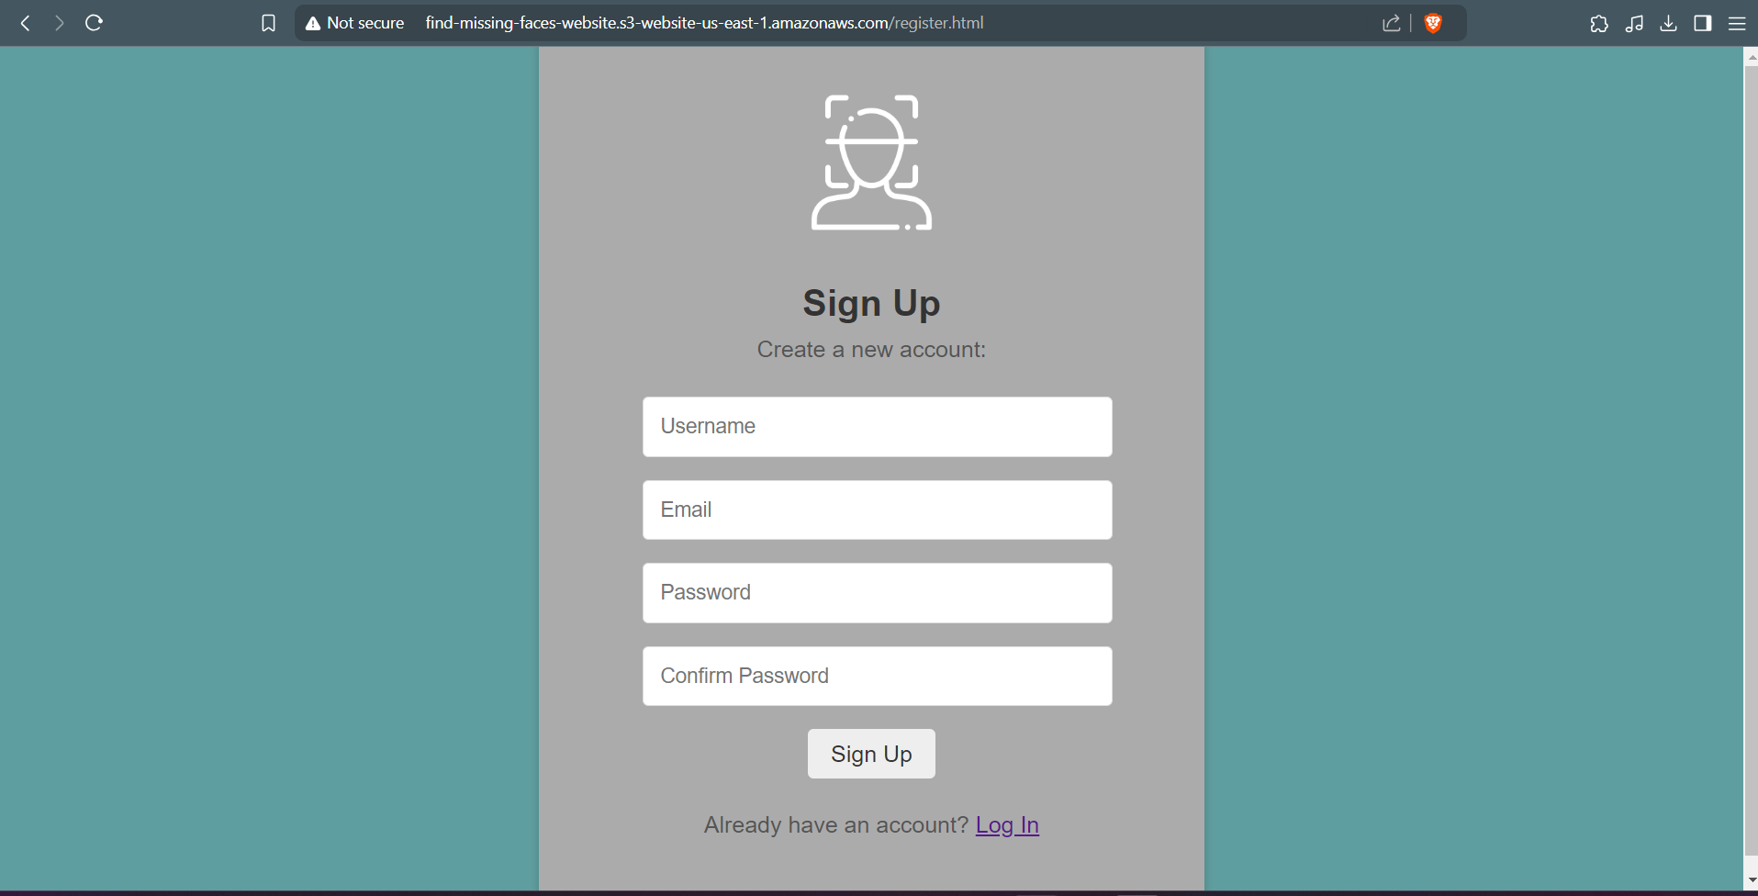

Figure 3. Sign Up Page - Email verification.

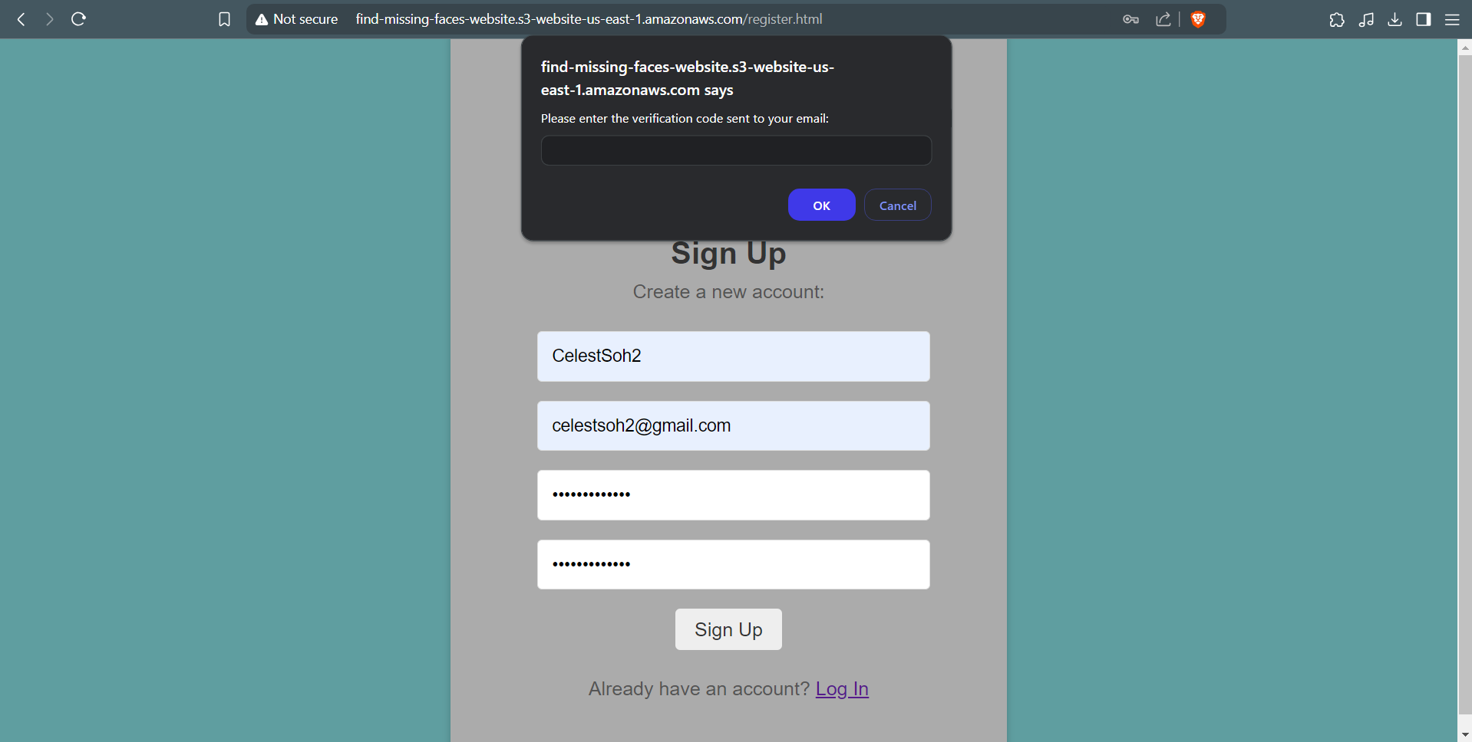

Figure 4. Sign In page - Logging in via username for registered, logged out users.

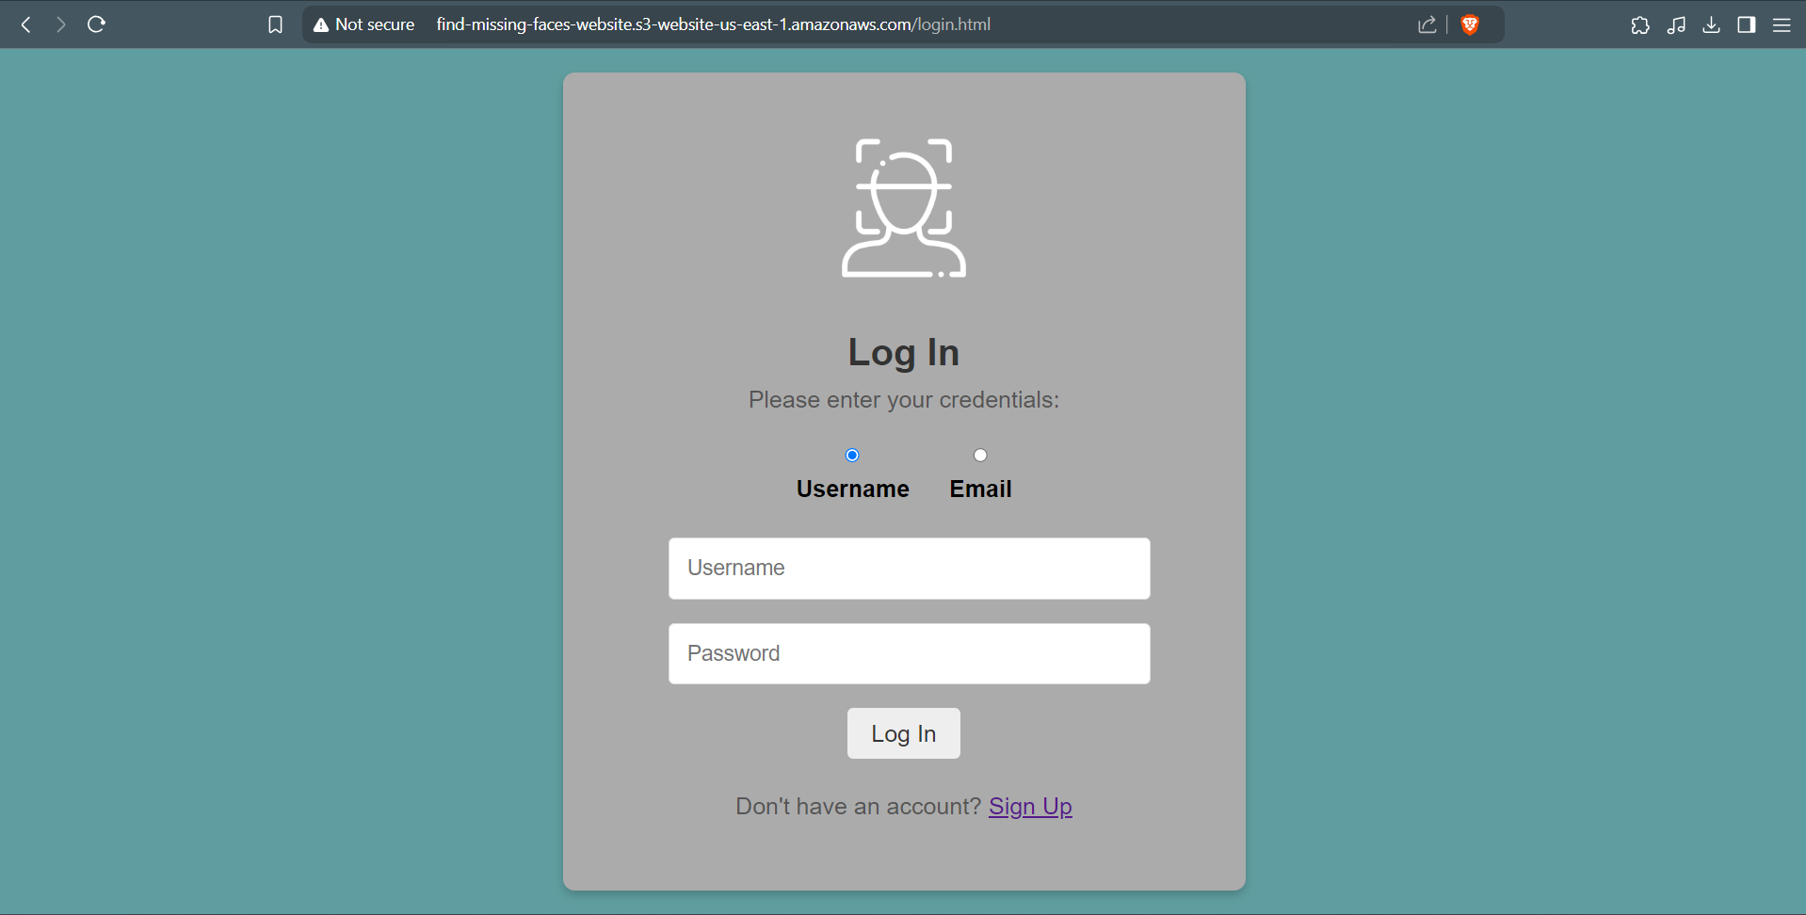

Figure 5. Sign In page - Logging in via email for registered, logged out users.

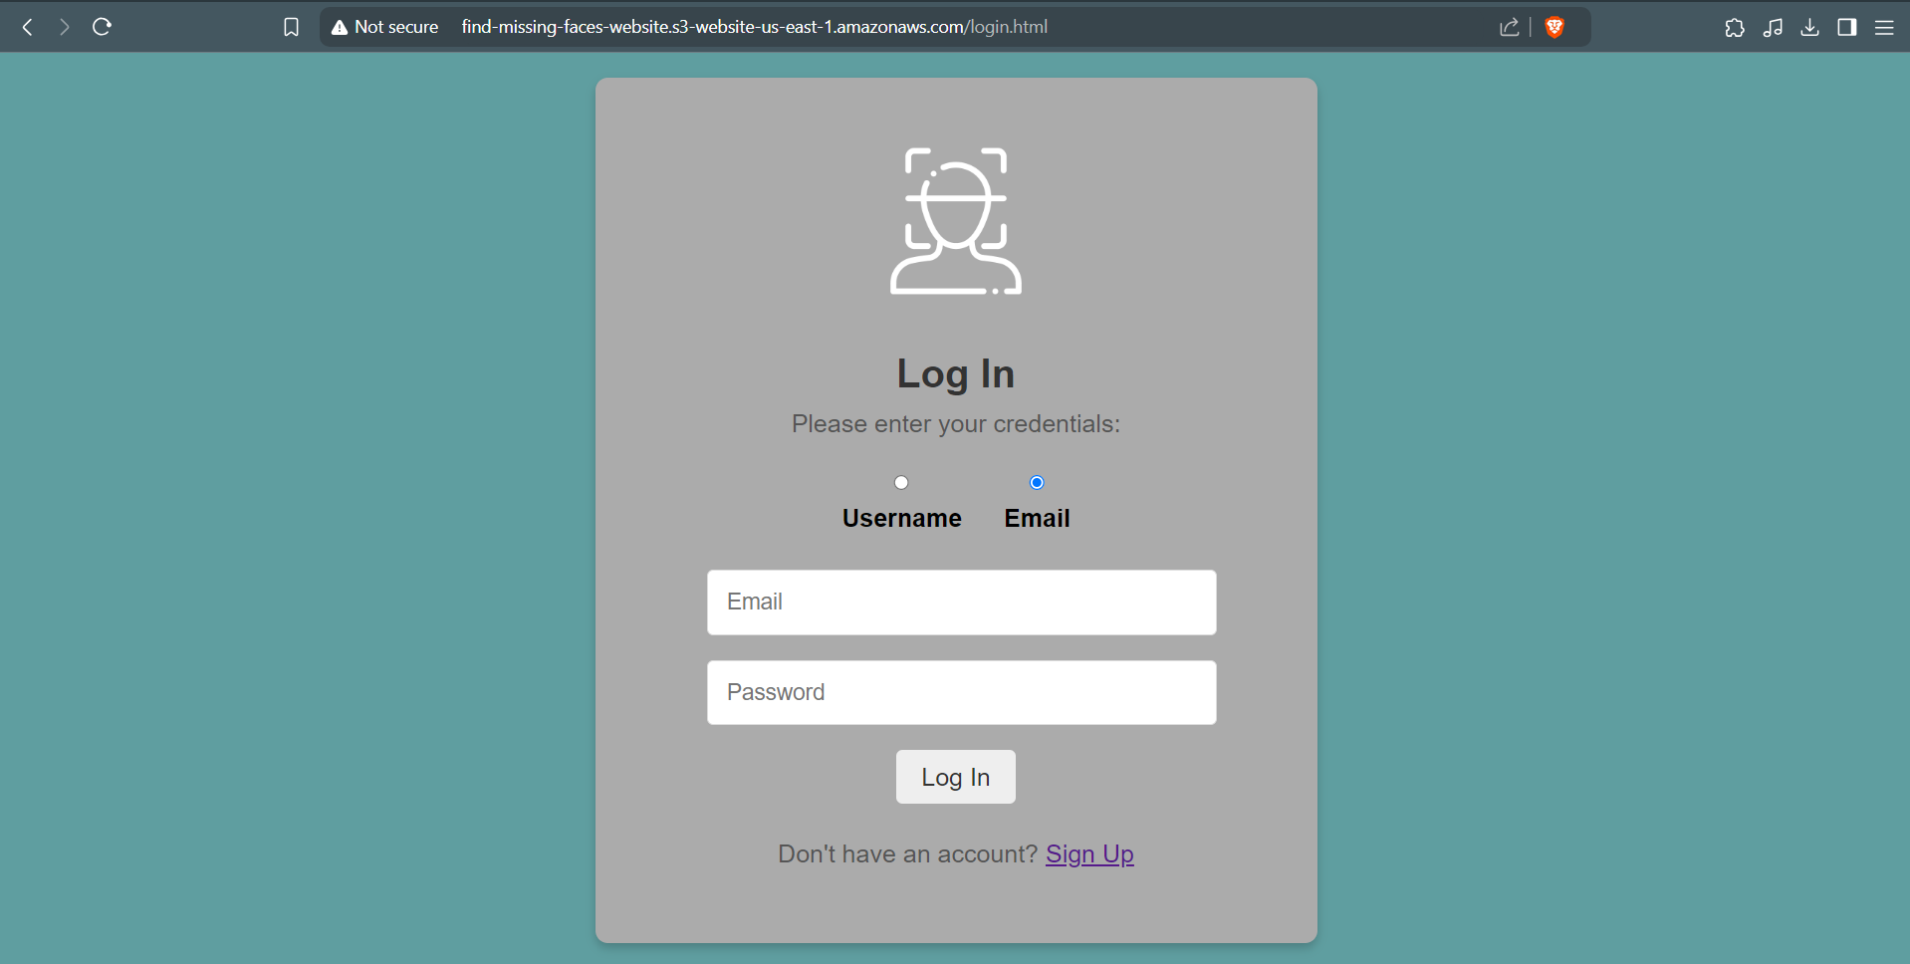

Figure 6. Homepage - Initial page for logged in users.

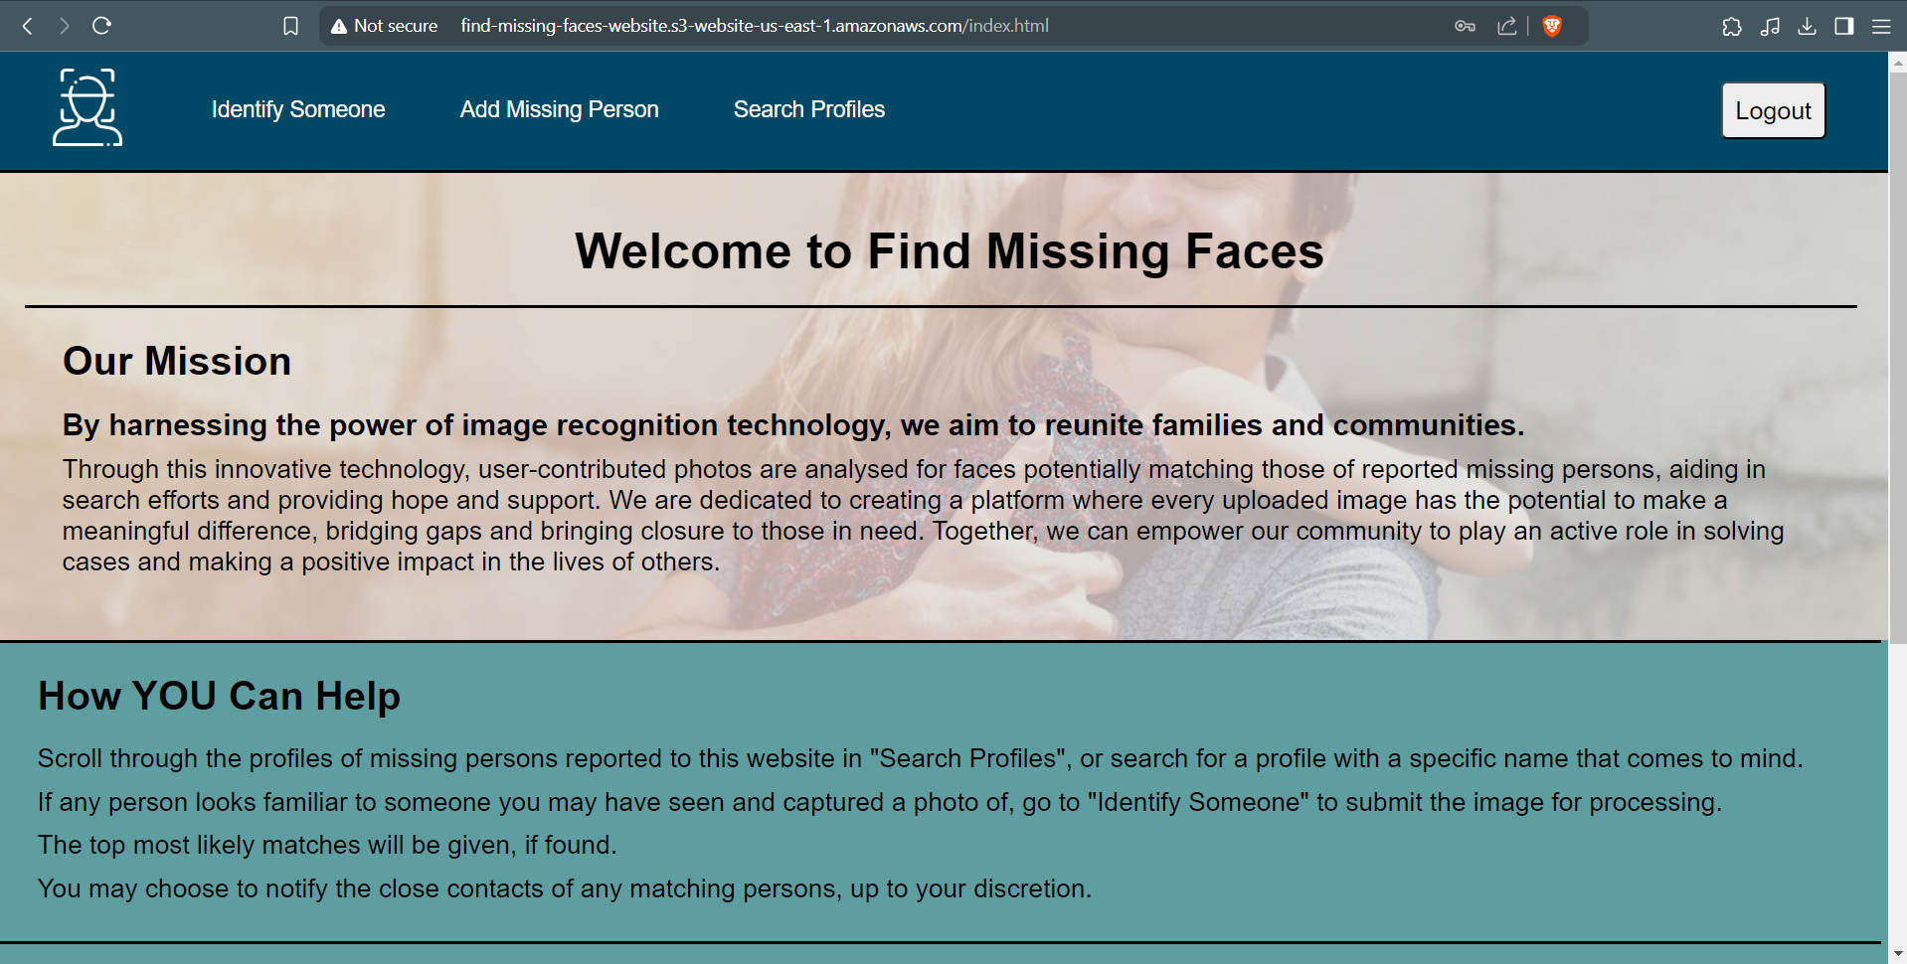

Figure 7. Identify Someone page - AWS Rekognition detects faces in an image and find matches. Top 3 matches outputted with similarity scores and bounding box is drawn on faces matching the missing people outputted, and an option to notify close contacts is given.

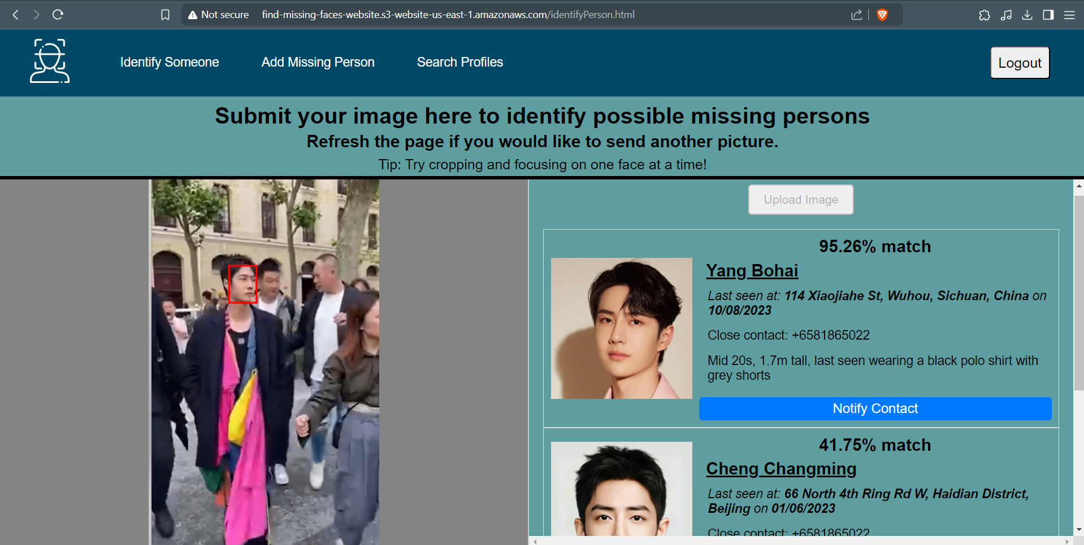

Figure 8. Add Missing Person page - For users to add a missing person's profile, including portrait and close contact's phone number. Displays portrait to be uploaded before submission.

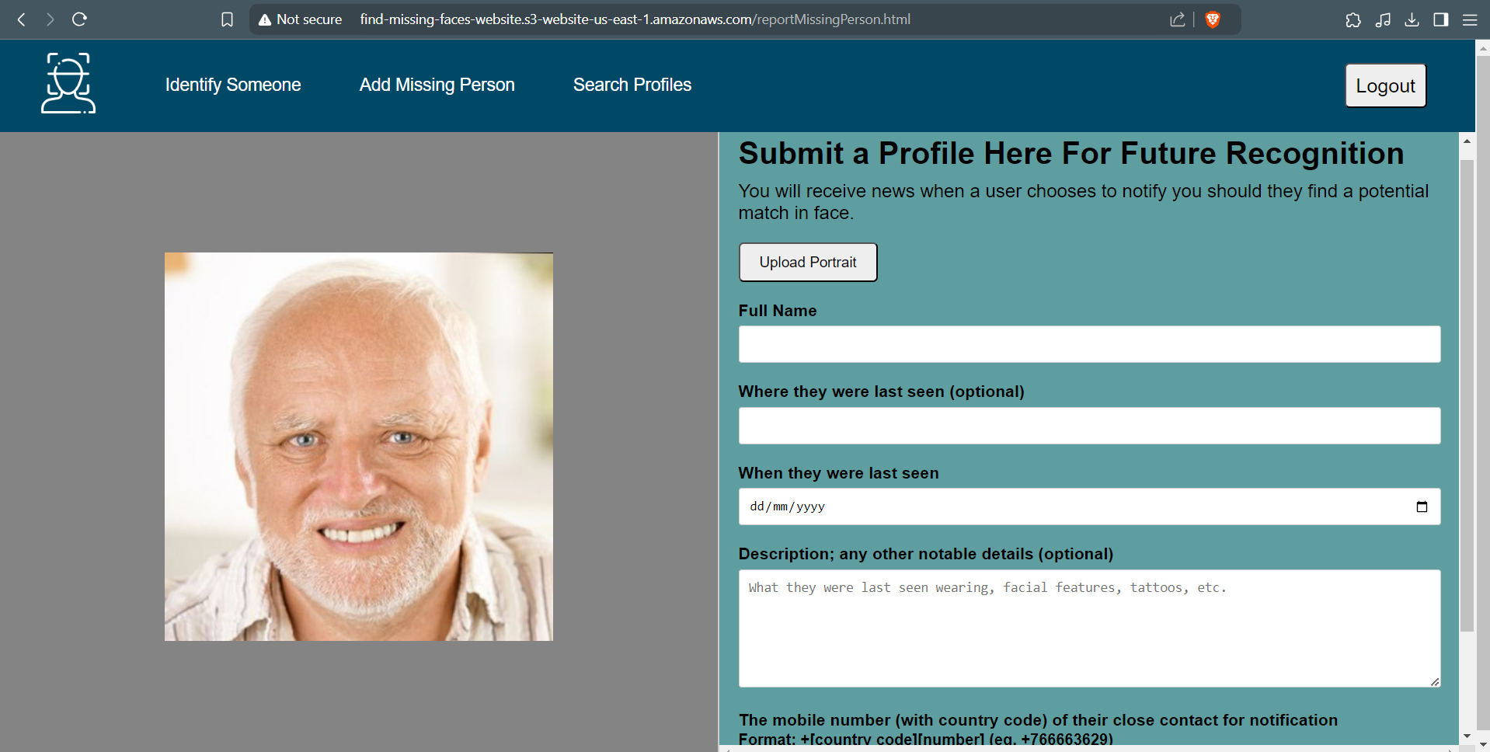

Figure 9. Search page - For users to find profiles by the missing person's name, or to browse all profiles.

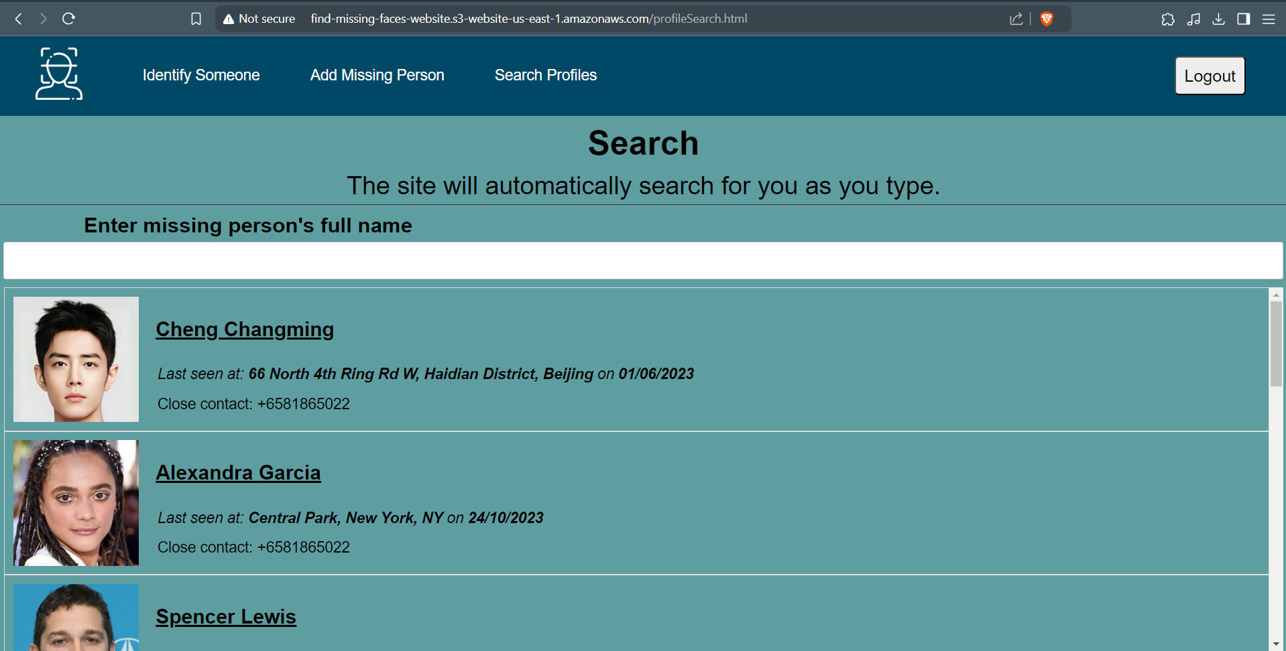

Figure 10. View Profile page - For users to view a specific missing person's profile, with the option to edit or delete it.

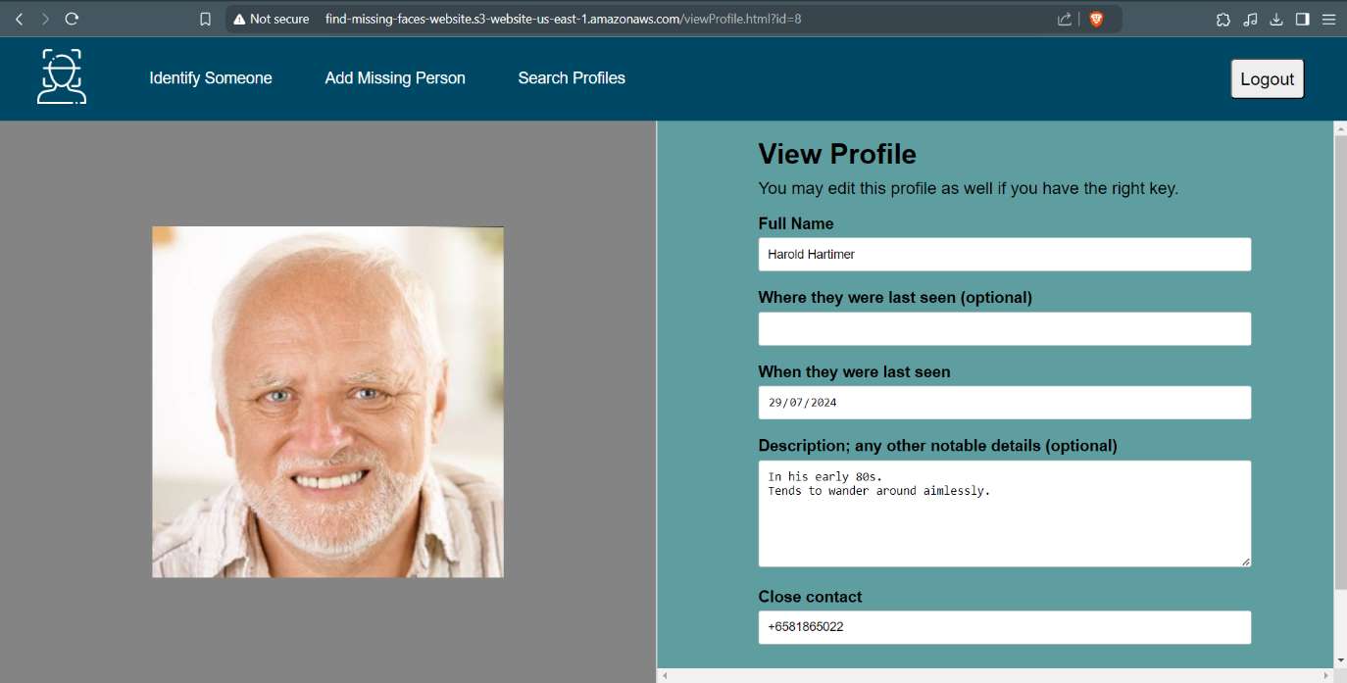

Figure 11. View Profile page - Users given the option to edit or delete the profile and if chosen, the user must enter the unique key given only to the user who created the profile.

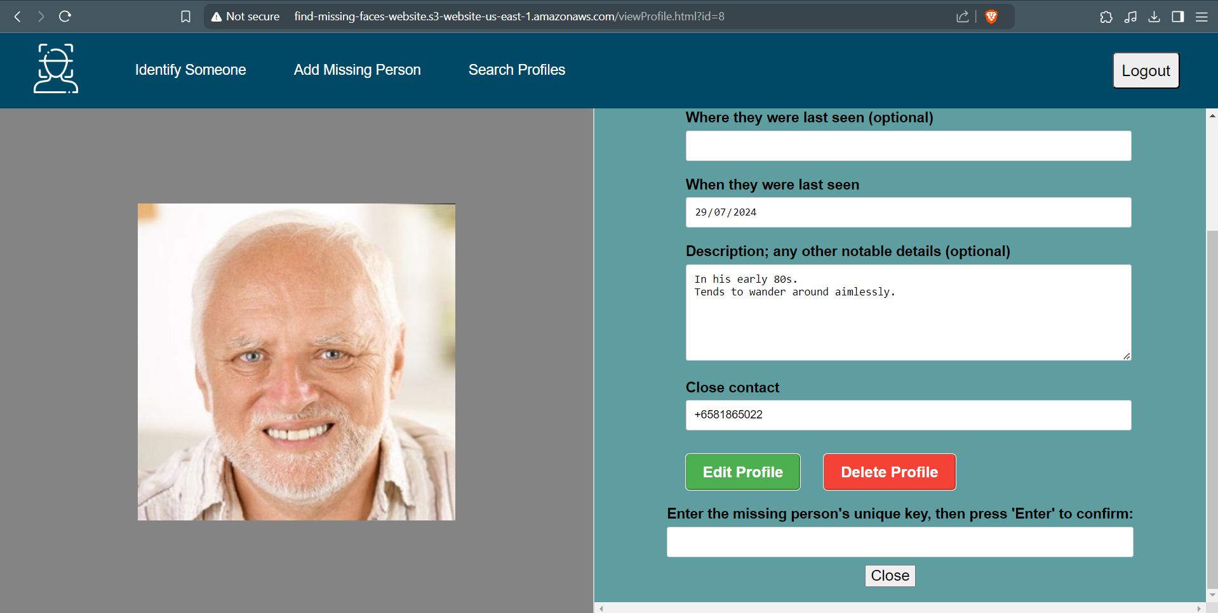

Figure 12. Edit Profile page - For verified users to modify the profile of the missing person.

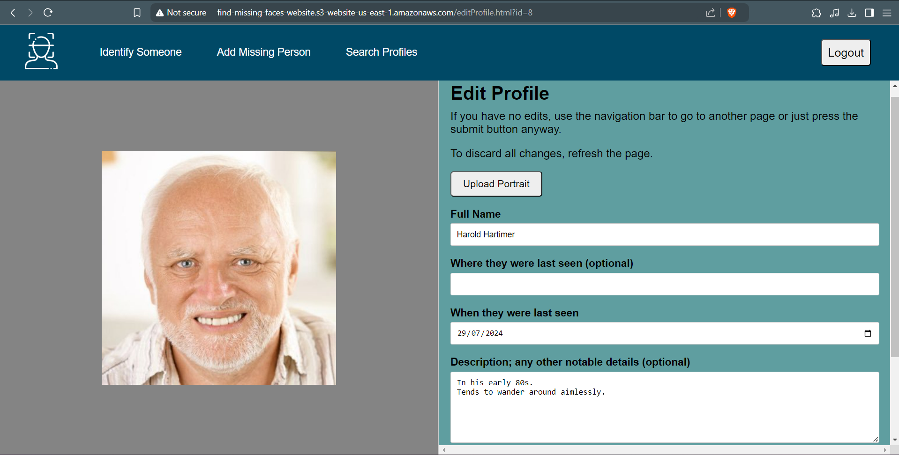

# Development of AWS Rekognition

Amazon Rekognition’s APIs for face detection and analysis are used.

Preparatory Steps

Since facial comparison is a key functionality of the website, faces submitted with profiles of the missing people will be indexed to derive its attributes, and these indexed faces will be stored in a collection to be used for comparison with detected faces in a scene image.

After indexing, a face is assigned a unique face ID. This will be retrieved and stored in the database for future profile retrieval when matches are found.

As such, a collection is first created in a simple lambda function to store the indexed faces before Rekognition’s API is used.

Rekognition’s CreateCollection operation is used to do this, using the Rekognition client from Python’s AWS SDK Boto3. [2]

Figure 13. Code to create the collection, with collection id "find_missing_faces_portraits_collection"

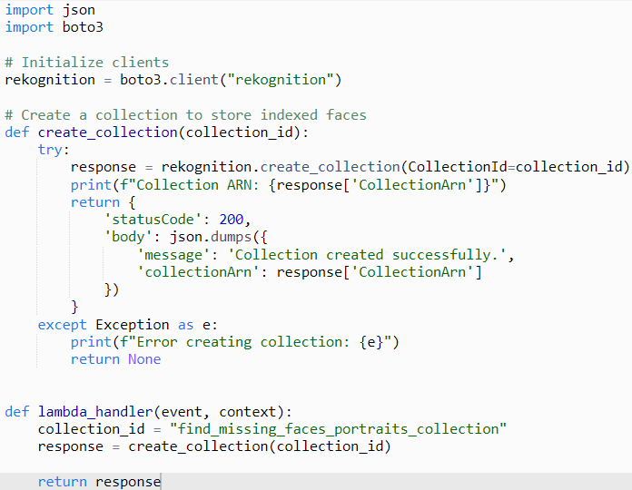

Integration – Database Operations

Rekognition is integrated with CREATE and UPDATE operations to index faces submitted during profile creation or update (if the image is changed). A function (index_portrait) indexes the face from the portrait stored in S3, then returns the face ID of the indexed face to be stored in the database.

It is also used to compare a submitted face with already indexed faces during these processes to ensure that no duplicate face is submitted. It uses SearchFacesByImage operation to do this. [2]

The issue with duplicated faces is that recognition will assign them the same face ID, so if multiple profiles have the same face, if 1 profile is deleted, the face ID for the other profiles will be deleted as well.

If a portrait submitted during profile creation or update is detected as a duplicate, the lambda code for the database operations will follow these steps:

1. index_portrait returns the face ID of the similar, already indexed face found.
2. Function executing CREATE (POST) operation checks if the face ID returned from index_portrait exists in the database and detects that it does.
3. The duplicate image is deleted from S3 (it was stored in S3 earlier for indexing) since it is not needed anymore.
4. A message is returned to the client-side JavaScript code which will notify the user that the face they submitted was a duplicate.

Since it is possible that a user is only submitting another portrait of their loved one, and not a separate user submitting the same profile, the notification of the issue includes the assurance to users that submitting this new image is unnecessary as all insights from this new face is already derived.

Figure 14. Code to index a face, which first checks if it is a duplicate. Used for CREATE (POST) and UPDATE (PUT) operations.

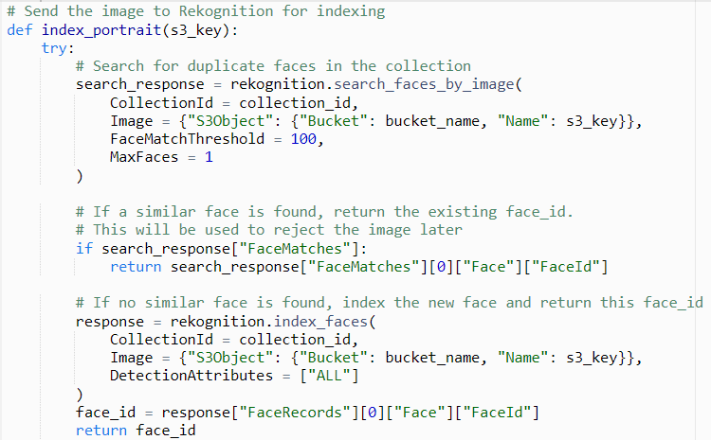

Checks if image is a duplicate.

Indexes the face here if the input is not a duplicate.

Figure 15. Code excerpt for CREATE (POST) operation, which checks if index_portraits returns a face ID already in the database, meaning a duplicate was found, then does the mentioned steps if a duplicate was found.

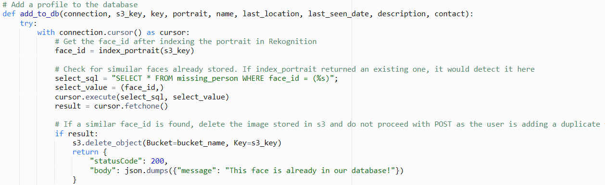

Rekognition is integrated with the DELETE operation as well, where the face ID will be deleted from the collection when the profile is deleted.

Integration – Image Analysis

Rekognition’s primary usage is for analysis of scene images submitted by users.

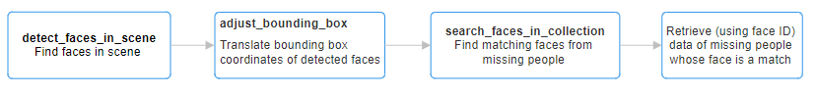The flow of image analysis is as shown:

1. A function using the DetectFaces operation (**detect_faces_in_scene**) detects faces in the image (the number of faces it can detect depends on the clarity of facial features in the input such as the eyes and mouth). [2]
2. **detect_faces_in_scene** returns all detected faces, each containing attributes including:
   1. Bounding box (area where face was found).
   2. Coordinates of facial landmarks (facial features).
   3. Facial attributes (age, gender, etc).

**detect_faces_in_scene** also returns the OrientationCorrection value from DetectFaces, which indicates the degree at which the image is tilted. [2]

This is required in case the image was orientated strangely (eg: upside down) and the bounding box values must be translated.

1. Afunction to adjust bounding box coordinates (**adjust_bounding_box**) retrieves from **detect_faces_in_scene**’s output:
   1. Bounding box coordinates of each detected face.
   2. OrientationCorrection value.

to translate bounding box coordinates to suit the image’s orientation.

It returns the translated bounding box coordinates.

1. A function to find indexed faces matching faces in the scene image (**search_faces_in_collection**) initialises an array to store results (search_results), then iterates through each detected face to:
   1. Retrieve translated bounding box coordinates from **adjust_bounding_box**’s output.
   2. Use SearchFacesByImage operation to retrieve matching faces from the collection of missing people’s indexed faces. [2]
   3. Compile a dictionary containing:
      1. Translated bounding box coordinates.
      2. Face ID of the match.
      3. Similarity score (percentage of how similar the missing person’s face is to the face in the image).
   4. Append the dictionary to search_results.

Once iteration is completed, it returns the results array.

1. Retrieve from the database the profile data of missing people the match’s face IDs belong to.
2. Compile the data for each matching missing person along with the bounding box of the corresponding scene face and the similarity score scene face and the missing person’s face.

Input Handling

The client-script ensures that selected portrait inputs are of valid image formats by checking the extension. Valid files are then encoded to bae64 format before submission.

During profile creation and update, the base64-encoded image from the client will be decoded to binary form (for recognition processing) before storage in S3. A unique S3 key will be generated to store the image in the S3 bucket for profile portraits using the missing person’s name (as of submission) and the timestamp of the current timing in this format: name_timestamp. The S3 key is then used to specify the image input when checking for duplicate faces and face indexing.

The function for indexing portraits is wrapped in a try-catch to handle the case where a face is not found in the submitted portrait. The lambda function returns a message which is relayed to the client once the response is captured by the client-side script.

Figure 16. Code excerpt of function for facial indexing which catches the error occurring when a face isn’t found in the portrait image.

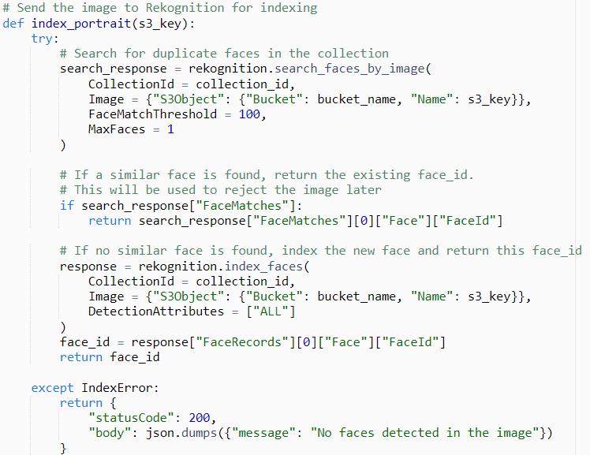

Finally, the **detect_faces_in_scene** function used during analysis of scene images returns an OrientationCorrection value indicating how the image is orientated. (subject to if the image contains metadata regarding orientation [2]. If not, **detect_faces_in_scene** returns the default “ROTATE_0” value meaning the image need not reorientation.) This is to account for images abnormally orientated.

Output Handling

Bounding boxes drawn for faces detected in scene images will have their coordinates translated according to the OrientationCorrection value returned by **detect_faces_in_scene** to accurately pinpoint the face regardless of image orientation.

Custom Configurations

* Examples of configurations are the text within the beige boxes of the stated Figures.

When detecting duplicate faces during profile creation and update, FaceMatchThreshold and MaxFaces attributes for the SearchFacesByImage operation are set to 100% and 1 respectively to find any one face in the missing people portraits collection that may be the exact same [2]. (Refer to Figure 14)

During face indexing and when detecting faces in a scene image, all facial attributes for each face are saved for comprehensive facial comparison based on as many criteria as possible [2]. (Refer to Figures 14 and 17)

Figure 17. Code excerpt of a function to detect faces in a scene image submitted by a user.

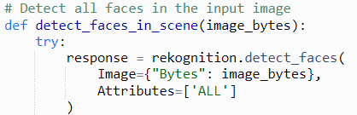

For facial comparison between faces in a scene image and indexed faces of missing people, FaceMatchThreshold is set to 10% so that only missing people with similarity scores above 10% are considered matches. This is so that faces too dissimilar are not considered (resulting in similarity scores below 10%) while accounting for the fact that submitted images may not be of the best quality and that the angle and lighting of the image may also affect Rekognition’s attribute values (resulting in lower similarity scores).

Figure 18. Code Excerpt of a function that compares detected faces in a scene image to indexed faces of missing people submitted to the website.

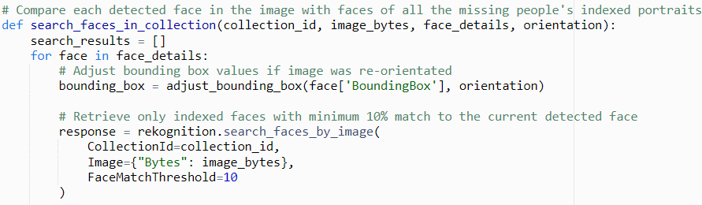

Performance Optimisation

Unnecessary storage in S3 is reduced by processing the images locally for scene images.

For example, when a user submits a scene image for missing people to be identified in, the image is not stored in S3. Instead, it is processed by Rekognition directly after decoding in the lambda function.

# Development of Amazon Simple Notification Service (SNS)

Amazon SNS is used to notify close contacts of missing people when a user who submitted a scene image potentially containing the missing person chooses to.

Note:

Due to Learner Lab restrictions, Amazon SNS for SMS can only be used in sandbox mode.

This means that although any phone number can be subscribed, messages will only be delivered to phone numbers specified as a sandbox destination number, which I specified as my personal phone number. The profiles used as demonstration all use this phone number as a close contact as a result for testing purposes, but since successful SMS delivery has been proven for this phone number, it means Amazon SNS for my web application works.

Figure 19. AWS Management Console for Amazon SNS with my personal contact as a verified sandbox destination number.

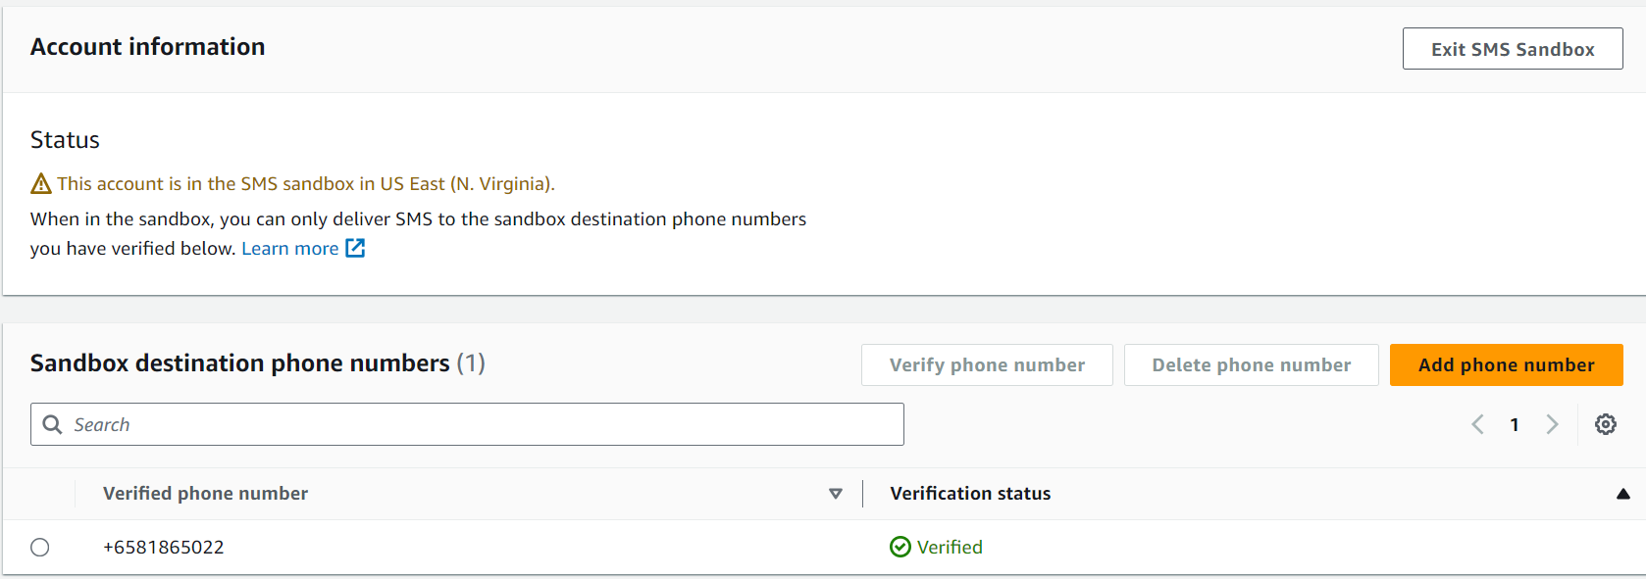

Integration

During profile creation for a missing person, an SNS topic is created for updates. A unique topic name comprising of a unique 6-digit alphanumeric code and the missing person’s name (as of profile creation) is created in this format: code_name. Then, CreateTopic [3] is used to create a new SNS topic under that topic name and the topic ARN is saved in the database for future reference (when sending a message). Furthermore, Subscribe [3] is used to subscribe the specified close contact to the topic for them to receive future SMS notifications.

During profile update, if the close contact’s phone number is changed, the old number is unsubscribed from the topic using the Unsubscribe. Afterwards, Subscribe [3] subscribes the new number to the topic.

During profile delete, the topic will be deleted entirely using DeleteTopic [3].

During image analysis, if the user decides to notify the contact of a missing person found as one of the matches, the user must enter some details about the image (location, date, and an optional description) to send to the contact. After confirming that they would like to send the message with the details specified, Publish [3] is used to send the message (compiled from the image details entered) to the missing person’s topic ARN.

Figure 20. A form for user to enter details of the image where the missing person was identified by Rekognition

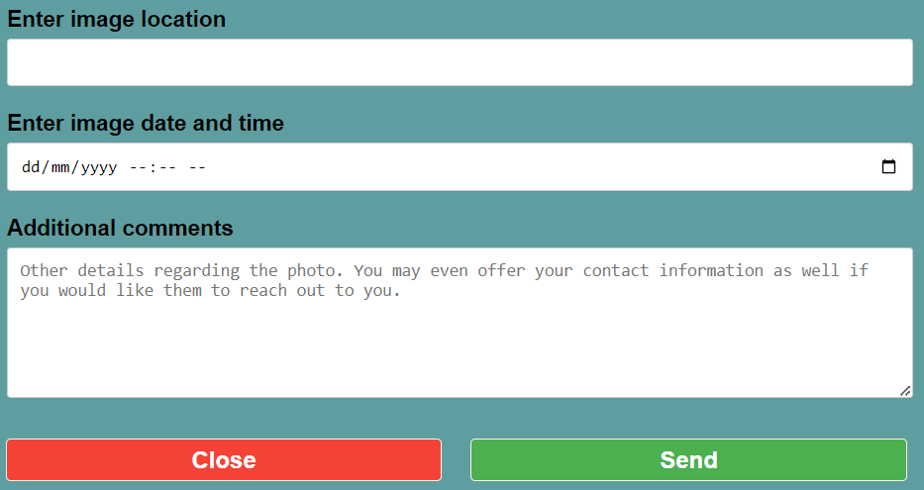

Figure 21. A sample SMS message if the user who submitted the scene image adds a description when notifying the person's close contact.

Figure 22. A sample SMS message if the user who

submitted the scene image chooses not to add a

description when notifying the person's close contact.

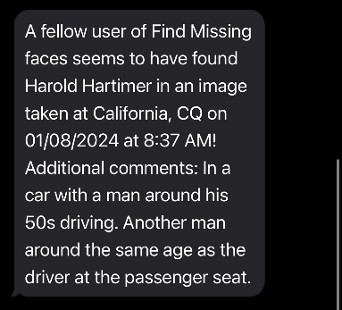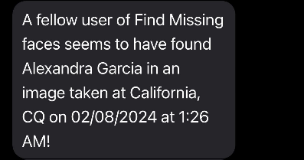

Input Handling

The client-side code ensures that the submitted phone number is of the E.164 format (+[country code][phone number]) required by Amazon SNS [3] and checks that the length of the phone number is valid.

Figure 23. Detailed instructions and a sample number are provided when users are entering profile information for the missing person. The '+' sign is also added for them.

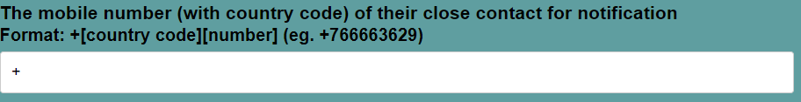

Figure 24. Code excerpt of the various checks done to ensure that the contact entered is of the correct format and is of reasonable length. The format is checked using a regular expression.

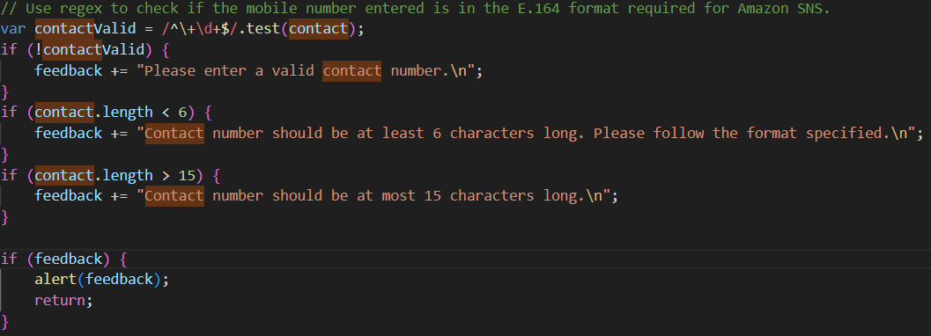

When a profile is updated, the previous phone number of the close contact is retrieved to check if the one sent during update is different to decide if it should proceed with unsubscribing the old contact and subscribing the new one.

Output Handling

The topic ARN returned from CreateTopic used in profile creation, along with the close contact’s mobile number, are stored in the database.

Custom Configurations

When creating the missing person’s topic, Name for CreateTopic is set to the generated name specified earlier in the Integration section.

Figure 25. Function to generate a topic name.



Figure 26. Function to create an Amazon SNS topic. It checks if the generated topic name is unique and will regenerate another topic name if it is not. Once the topic name is verified to be unique, CreateTopic creates the topic with the name.

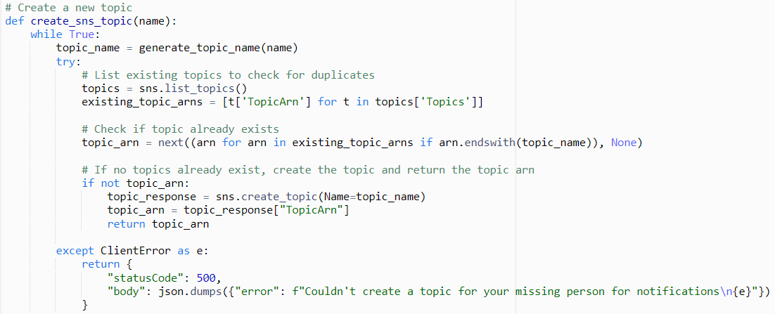

1. Generate a topic name.
2. Retrieve existing topics using ListTopics.
3. Check if the name already exists based on the ARNs of existing topics.

If it does not exist, create a topic with the name and return the ARN.

SMS protocol is used for this notification system as it is the most convenient point of contact for the web application. Emails may be detected as spam, which results in the notification not being shown to the close contact.

When subscribing contacts, the topic ARN, the protocol to use and the provided phone number in E.164 format is passed in to the Subscribe action.

Figure 27. Subscribe action to subscribe the close contact to the topic. The missing person's topic ARN and the close contact's phone number in E.164 format is provided along with specification that the notification is to be send via sms protocol.

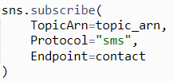

Performance Optimisation

Standard type SMS messaging is chosen for high throughput and low latency since less processing is required than if First-In-First-Out (FIFO) is used, because messages need not be delivered in any order. [3]

Figure 28. Sample topic details in AWS Management Console.

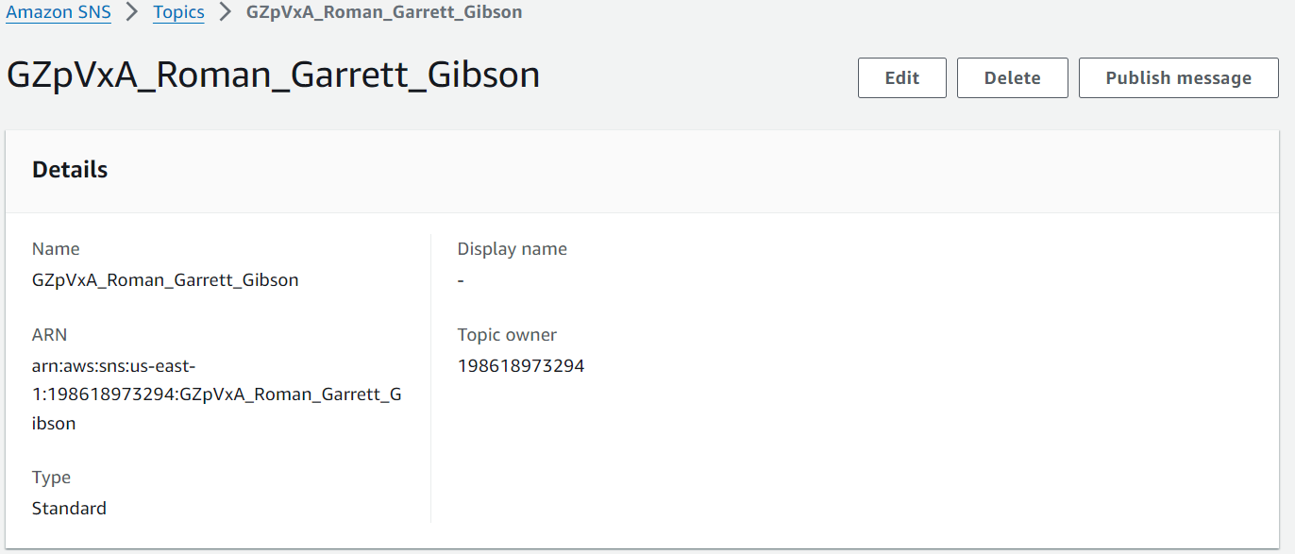

# Development of Amazon Cognito

Preparatory Steps

To use Amazon Cognito Service for authentication, a user pool for Find Missing Faces is created in the AWS Management console to store all users. [4]

Integration

Amazon Cognito service is used to sign up new users (with verified emails) and signs in existing users to the website. This provides an additional layer of security by ensuring that only verified individuals are use the app.

Once users register and verify their emails, or once users successfully sign in, their tokens required to assess user state (whether they are signed in or not) are stored in the browser’s local storage. User state is verified at every page the user navigates to.

A new user signs up with their email and specifies a username and password they would like to use, both of which must be unique. (Refer to Figure 2) In future, the user can choose between using their email or their username as their identifier along with their password when signing in. (Refer to Figures 4 and 5)

Every page of the website offers a button for users to log out when they wish to. (Refer to Figures 6 to 12)

Input Handling

The inputs for Password and Confirm Password fields in the registration page are verified before the data is sent to the lambda function handling authentication. If they are the same, it will send the data over. Else, it will notify the user and not proceed until the two fields are the same.

When a new user signs up, the lambda function handling authentication verifies if the provided email already exists and will send a message to the client-side code if it does, for the client-side code to then inform the user of this. The function handles a user specifying an existing username or an invalid password similarly.

Figure 29. Code Excerpt of function to sign up a new user

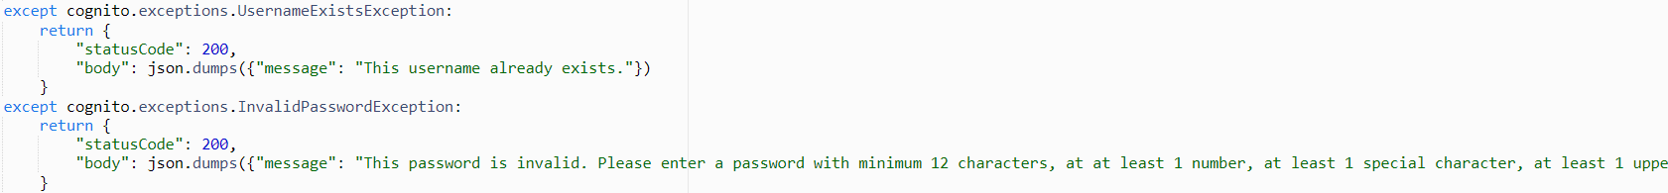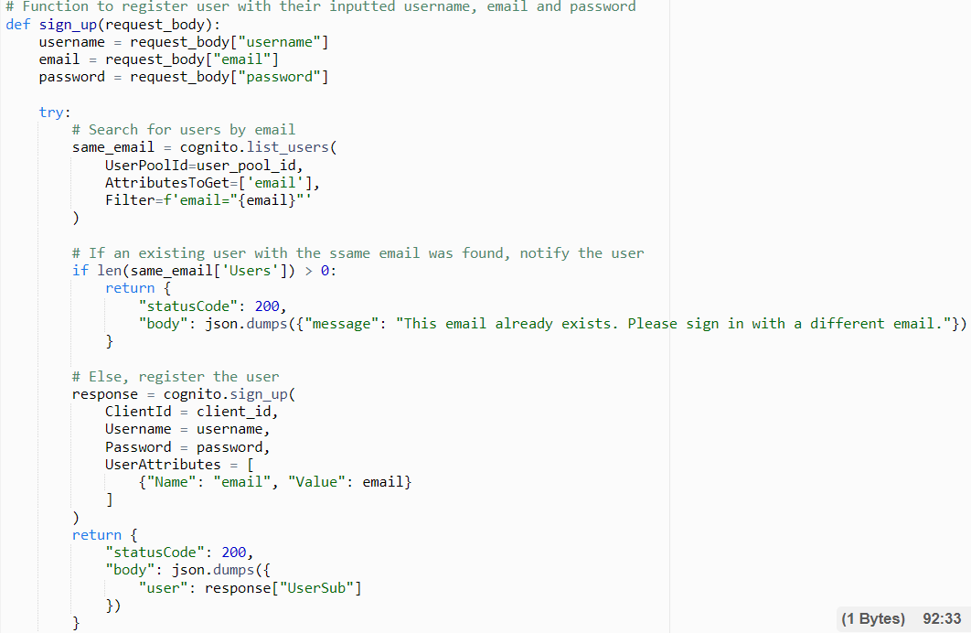

Catches UsernameExistsException to relay message that the username already exists

Signs up the user if the email is new.

Checks if the user’s email already exists in the user pool using ListUsers, filtering by matching email.

Catches InvalidPasswordException to relay message that the password is invalid.

Once a user signs up, they must enter a verification code and the code entered is checked by Cognito [4]. If the code is incorrect, has expired, or if the verification process encounters some error, another code is sent. Once the user enters the correct code, they are signed in to the website.

For sign in, Cognito verifies the identifier (username/email) and password submitted [4]. The function that does this is wrapped with a try-catch to catch errors specifying incorrect credentials, or non-existing identifier.

Figure 30. Code excerpt of the function to sign a user in which catches errors regarding invalid credentials and sends a message for the user to understand and rectify the issue instead of an error that will affect the process.

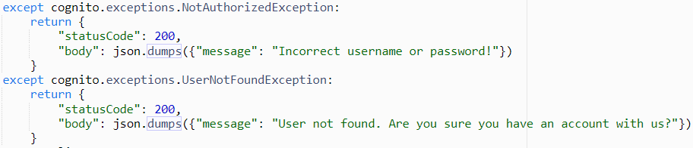

Output Handling

ID token, Access, and Refresh Tokens along with the username is stored locally in the browser’s storage. They will be accessed as the user navigates around the website when each page checks the user’s authentication state.

Custom Configurations

As Find Missing Faces intends to utilise public contribution, users are allowed to sign up on their own rather than having to be invited. [4]

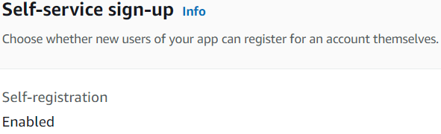

Required attributes are also limited to just email to simplify the authentication processes for users. [4]

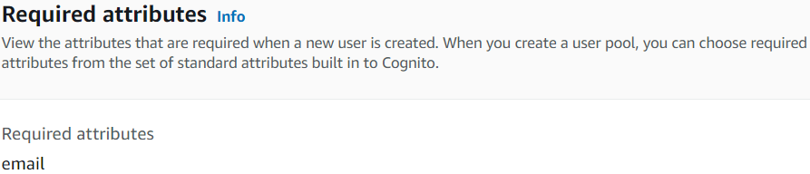

Strict username and password requirements are set for user pools:

* Usernames are case-sensitive so even similar usernames but in different case are considered duplicates as seen in the screenshot below [4]:

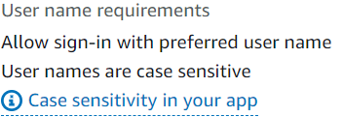

* Passwords must fulfil the requirements stated in the screenshot below: [4]

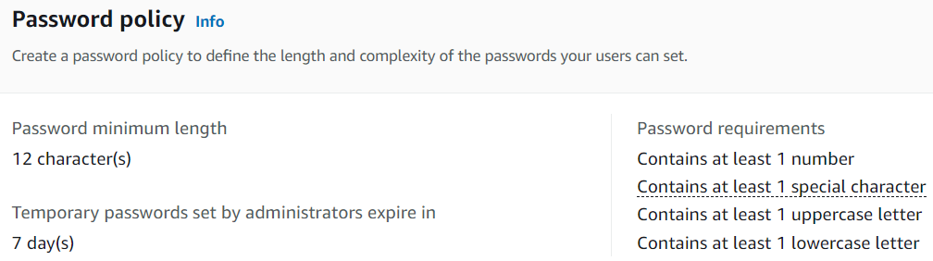

Email verification is required for users who signed up as well. Verification codes are sent by email as it is the common platform for verification. [4]

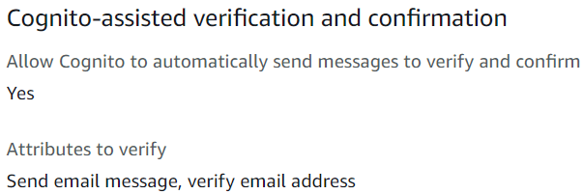

Users signing in may use either their username or email as their identifier, depending on their preference. [4]

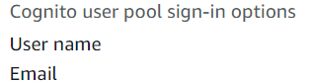

When signing in, InitiateAuth action is used and its Authflow is set to USER_PASSWORD_AUTH, which is a simple authentication flow requiring just a username or email with a password [4], which will be passed in as AuthParameters.

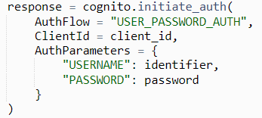

The time limit for the Access and ID tokens produced when users have been authenticated and signed in is set to 2 hours so that users are neither signed out too quickly nor signed in for too long. The refresh token time limit is left as the default [4]. Authentication flow session duration is set to 3 minutes so that users do not take too long to sign up or sign in while having enough time to do so, considering the need to wait for a verification email during sign up.

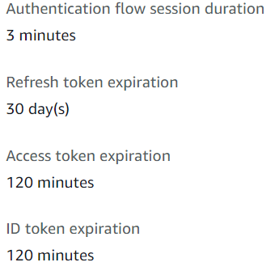

Performance Optimisation

Tokens used to check authentication state are stored in the browser’s local storage to prevent the user being signed out if they refresh the page, providing convenience.

# Deployment process

Service Dependencies

Services required for website deployment were:

* Amazon Simple Storage Service (S3)
  + Stores webpages.
  + Hosts static website.
  + A separate bucket stores portraits of missing people.
* AWS Lambda
  + Contains codes for website functionality in lambda functions.
* Amazon API Gateway
  + Triggers lambda functions for website functionality.
* Amazon RDS
  + Required for data retrieval.
* Amazon Cognito
  + Required for authentication.

Website Set-Up on S3

Before set-up on S3, the following were done:

* Create user pool for authentication.
* Set up bucket for portraits storage.
* Set up MySQL Amazon RDS database.
* Create AWS Lambda functions for website functionality.
* Create Amazon API Gateway HTTP API routes to trigger lambda functions. The API should be deployed to “findmissingfaces_test” stage.
* Integrate API routes’ URLs into client-side JavaScript code using fetch methods.

Find Missing Faces is set up on S3 using the following steps once logged in to the AWS Management Console [5]:

1. **Create website S3 bucket.**
   1. Go to Amazon S3 on AWS Management Console.
   2. Click “Create bucket” under “General purpose buckets”.

General configuration

* 1. Select “General purpose” Bucket type.
  2. Name the bucket. The bucket for this website was named “find-missing-faces-website”.

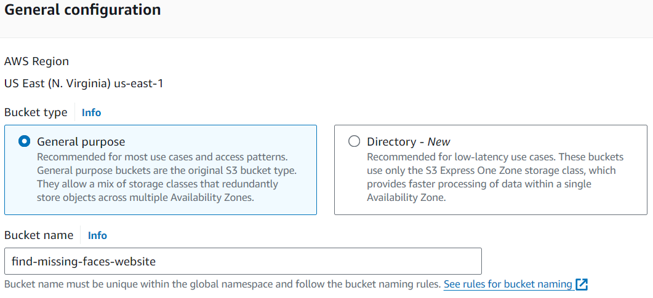

2

1

Object Ownership

* 1. Enable ACLs. This is to provide users with read access to the webpages.
  2. Select “Bucket Owner preferred” under Object Ownership so that the owner still has full control over objects in the bucket regardless of who added it.

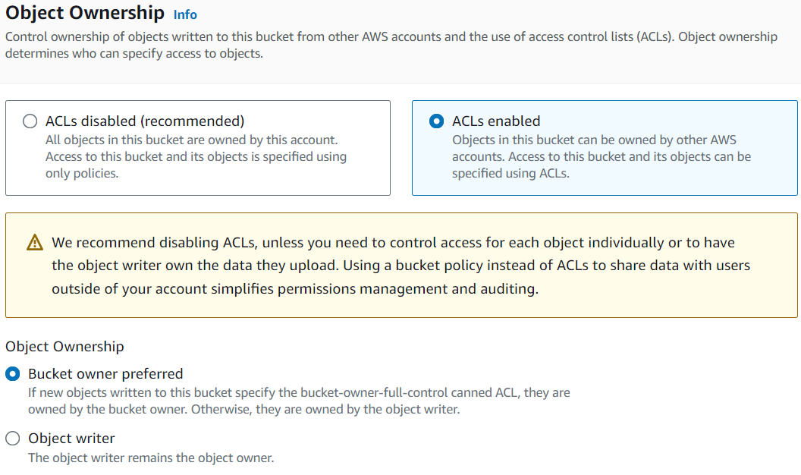

4=3

3

Block Public Access settings for this bucket

* 1. Allow public access to the bucket so that the website is publicly available. Do this by unchecking “Block *all* public access”. All other blocked settings beneath it will be unchecked automatically.
  2. Acknowledge that the bucket contents will thus be publicly accessible.

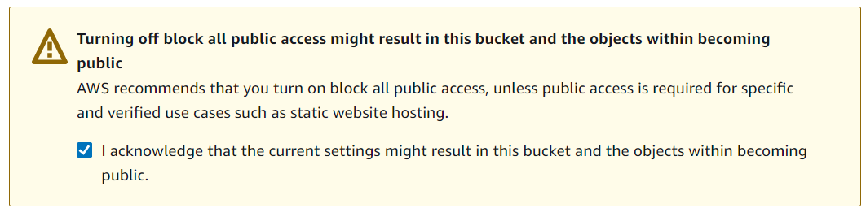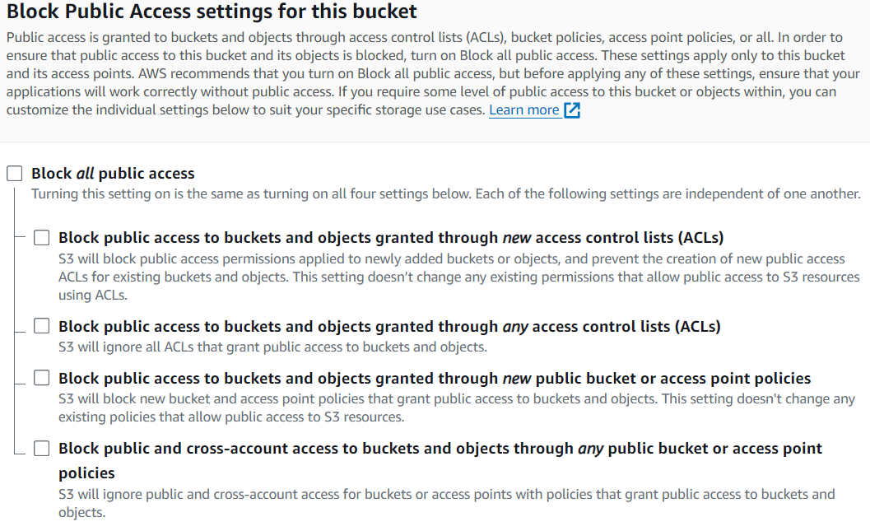

5=3

6=3

Bucket Versioning

* 1. Disable Bucket Versioning to always use the latest files uploaded.

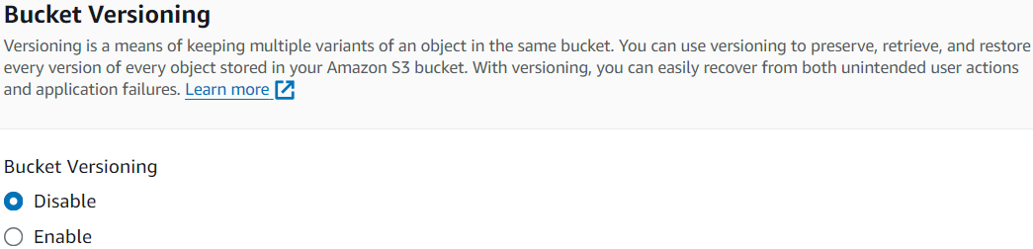

7=3

Tags

* 1. No tags added since they are not needed.

Default encryption

* 1. Select default “server-side encryption with Amazon S3 managed keys” encryption type for “Default encryption”.
  2. Leave “Bucket Key” under “Default encryption” as the default value “Enable”.
     1. Bucket Key is only relevant if “AWS Key Management Service key (SSE-KMS)” was chosen in Step 8.

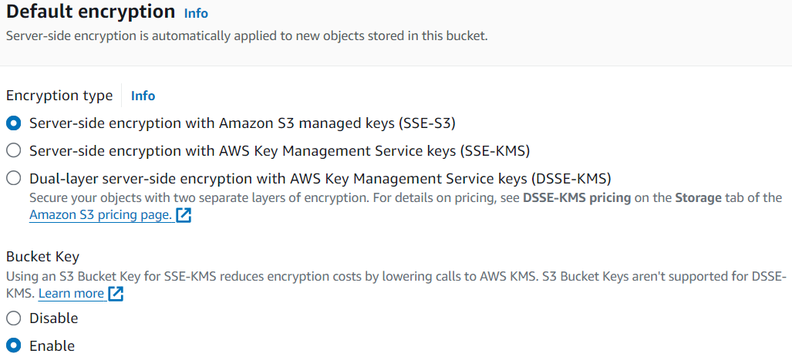

9=3

8=3

Advanced Settings

* 1. Disable “Object Lock” in “Advanced settings” as Bucket Versioning is disabled.

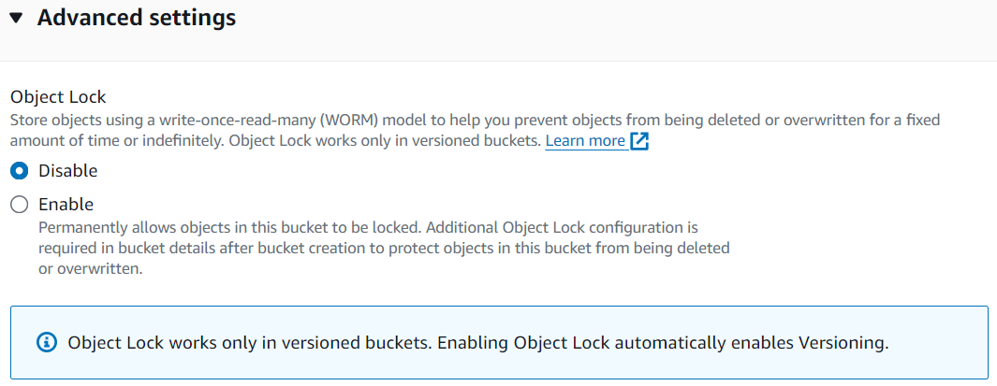

10

* 1. Click “Create bucket”.

1. 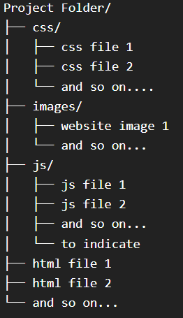**Upload webpage files.**

Note:

All webpage files for Find Missing Faces were

within a project folder with sub-folders for

images, css files and js files in a structure like this:

* 1. In “Buckets”, under “General Purpose Buckets”, select the bucket created (find-missing-faces-website).
  2. Under “Objects”, click the Upload button.
  3. Open the project folder in File Explorer
  4. Click ctrl + A to select all files and folders.
  5. Drag and drop the selected files and folders to this section of the Upload page:



Folders would automatically be created according to the structure given, like this:

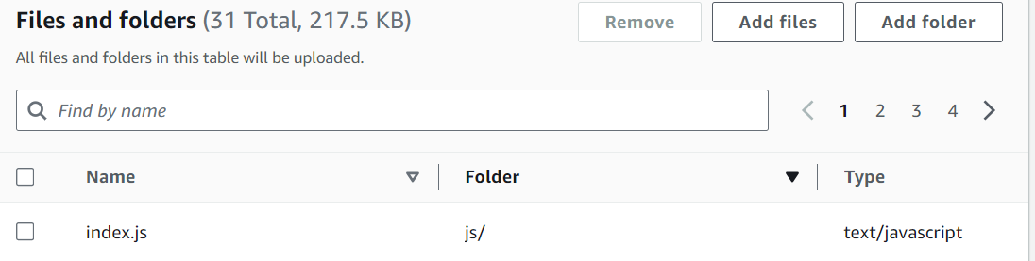





* 1. Open “Permissions”.
  2. Under “Access control list (ACL)”, select “Choose from predefined ACLs”
  3. Under “Predefined ACLs”, select Grant public-read access so that these webpage files are publicly accessible.
     1. 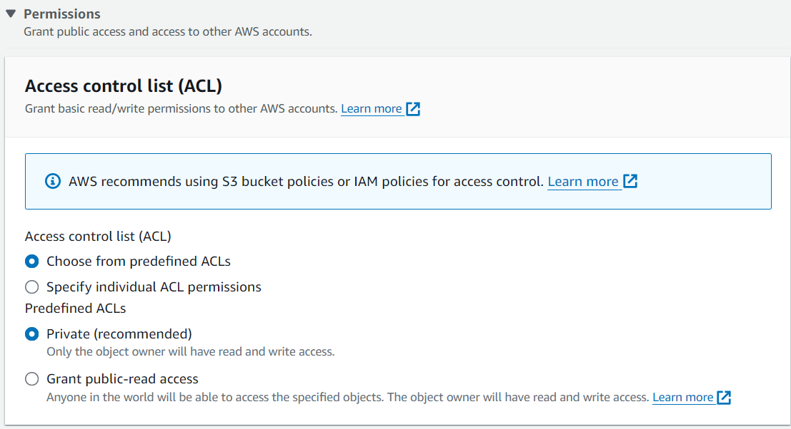All webpage files must be publicly accessible so that the client browser can access client-side code (.html, .css, .js, images) for webpage display and some functionality.

1

2

3

* 1. Leave properties as the default by skipping that section.
  2. Click “Upload”.

1. **Modify metadata for html files.**

In case of updates to css or js codes linked to the webpage, html files representing the structure of these pages, have Cache-Control defined as max-age=0 so that the updated code is used on default.

* 1. In “Buckets”, under “General Purpose Buckets”, select the bucket created (find-missing-faces-website).
  2. Under “Objects”, for each html file in the bucket:
     1. Click on the file to view its details.
     2. Under “Properties”, go to “Metadata”.
     3. Click the “Edit” button to go to “Edit Metadata”.
     4. Under “Metadata”:
     5. 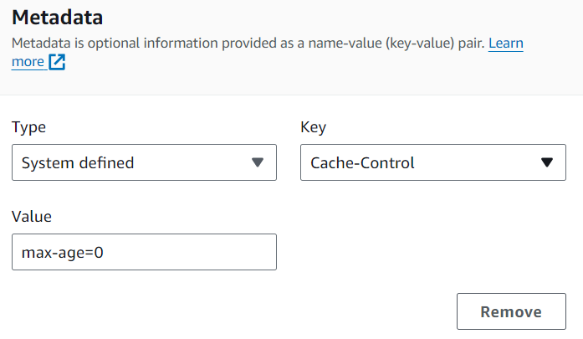Select Type as “System defined”.
     6. Select Key as “Cache-Control”.
     7. Set Value as “Max-age=0”.
  3. Click the “Save Changes” button.

1. **Enable static website hosting on the S3 bucket.**
   1. In “Buckets”, under “General Purpose Buckets”, select the bucket created (find-missing-faces-website).
   2. Click on “Properties”.
   3. Scroll down to “Static website hosting”.
   4. Click the “Edit” button to go to “Edit Static website hosting”.
   5. Under “Static website hosting”, select “Enable”.
   6. Select “Host a static website” for “Hosting type”.
   7. Select the homepage of the website as “Index document”. For Find Missing Faces, it is index.html.
   8. No error document is specified since there is none (except for the 404 page that only appears when there is an error when trying to retrieve a single profile’s details).
   9. Click “Save changes”.

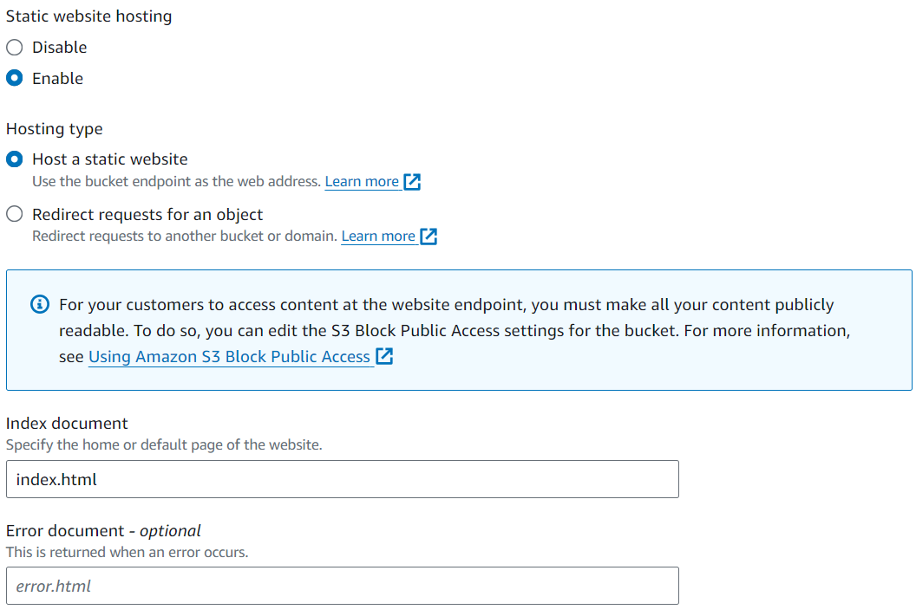

3

2

1

Troubleshooting Tips

Here are some tips in troubleshooting for the following issues that may arise:

No Access

Some pages may not be accessible, or some pages relying on the API such as View Profile do not work because there is no access provided. Not only must the webpage files on S3 provide public read access, but the CORS configuration for the website API in Amazon API Gateway must also be set properly to allow users to access the core functionalities.

Non-CORS Issue

If the issue is that webpage content cannot be seen or that the static webpage is not working (nothing happens when a button is pressed), it may be because one or more of the webpage files in S3 did not provide “Read” access for “Everyone (public access)” grantees in the bucket ACL policy or the Object.

If the html file is what’s not accessible (the webpage cannot be accessed entirely), check that Read access is provided to Everyone (public access) under “Permissions” for the .html file in the S3 bucket, like in Figure 33.

If you can open the page but there is no styling, or no required backend processes occurring, the issue may be due to restrictive access policies on the .css and .js files. Right click and select “Inspect”, then navigate to Sources and check if the .css and/or .js file required for the webpage to work properly are shown. If they are not, then it means that the .css or .js files are either referenced improperly in the html file, or there is no **Object** public read access set for them.

Figure 31. The .js and/or .css files required for the webpage should be revealed here as shown below. This is what is shown when index.html is inspected.

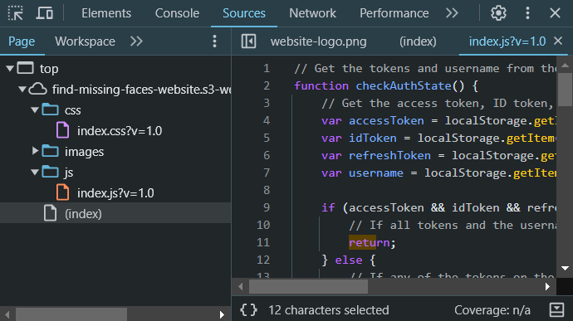

Figure 32. The ACL policy for .css, .js and other website files besides .html files should have Read access for **Object** granted to Everyone (public access) as shown below.

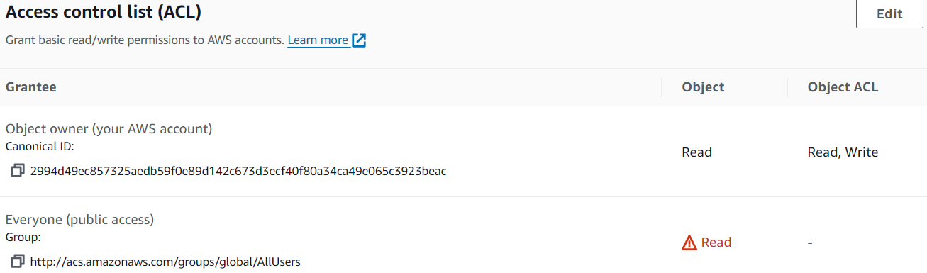

CORS Issue

This is likely caused by the API set up in Amazon API Gateway having a restrictive CORS policy [6].

Go to the Amazon API Gateway page in the AWS Management Console, then click on the API set up for the website under “APIs”. At the sidebar, under “Develop”, click on “CORS”. Click on the “Configure” button on the Cross-Origin Resource Sharing page to modify CORS configuration. The configurations should be [7]:

Access-Control-Allow-Origin: * (allow all origins)

Access-Control-Allow-Headers: * (allow all headers)

Access-Control-Allow-Methods: GET, POST, PUT, DELETE (the methods required for Find Missing Faces’ functions)

Access-Control-Expose-Headers: * (all headers)

Access-Control-Max-Age: 0 (no caching of CORS policy so latest policy is always used)

Access-Control-Allow-Credentials: NO (default)

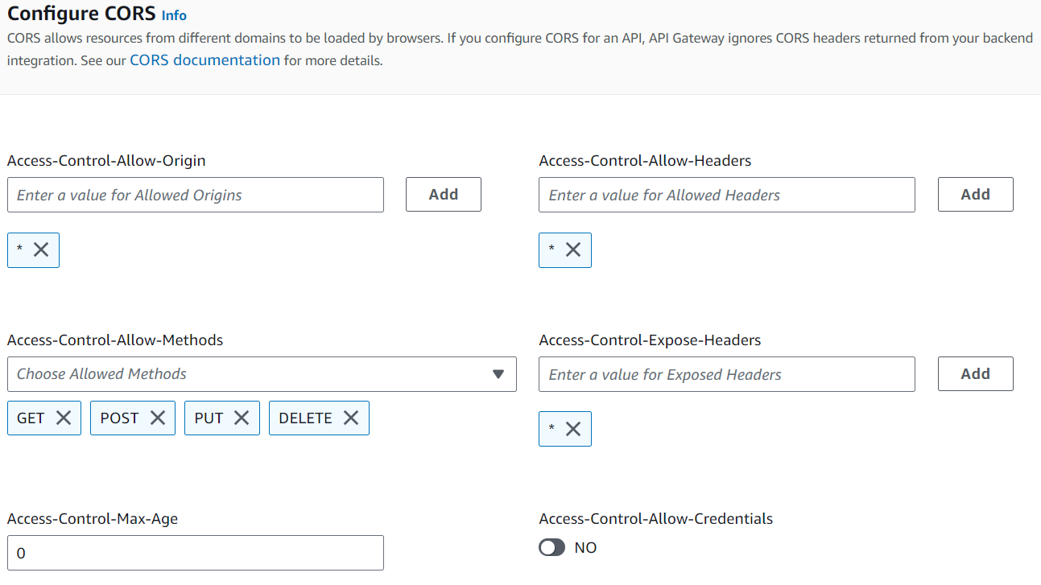

Content not updating

If webpage content is not updating even when you’ve reuploaded the .js or .css file linked to the .html file of the webpage, here are some ways you can troubleshoot:

Check the reuploaded file. Sometimes reuploaded files under the same name are not updated and need a simple refresh. Open the reuploaded file in the AWS Management Console by entering the bucket and navigating to the file’s location, then clicking on its name. Under “Properties”, find “Object URL” in “Object overview” and click on the URL to open the file.

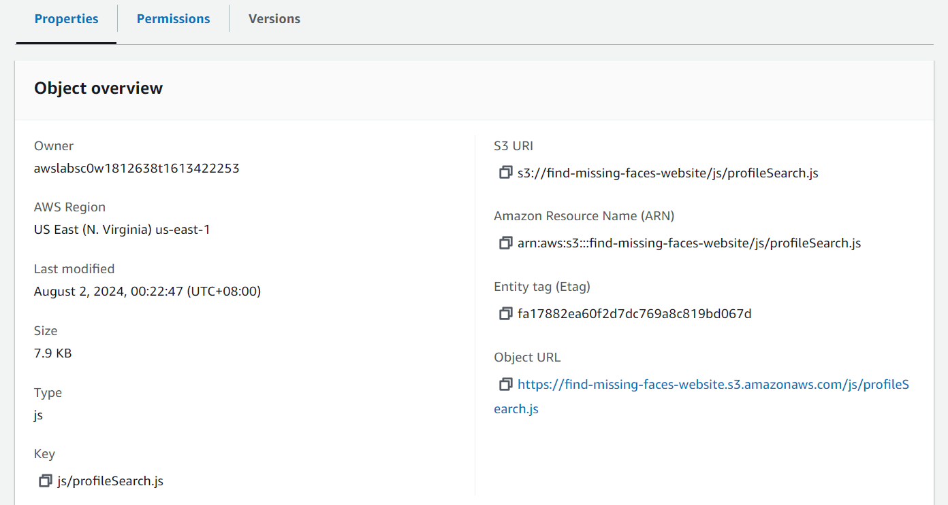

If you see that the file contents are unchanged, press Ctrl + R to reload and you should see the contents updated. Refresh the webpage and see if the changes show.

If that does not work, the .html file may need to be updated. Append “?v=1.0” to the file path provided in the link or script tags to force the file to use the latest version of the .css or .js file as shown here:

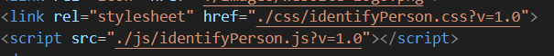

Assuming you reupload the .css or .js file again, you may need to remove “?v=1.0” for the content to be updated again.

Others

Sometimes, the website may not behave as expected despite there seemingly being no issues in the S3 configuration.

The issues may lie in lambda functions or client-side code. For example, failure to retrieve data required in a page, such as the Search Profile page which requires data of all profiles in the database.

Thus, it is good practice to add logging to any actions on the website, such as print statements in lambda functions when committing actions and console.log statements in JavaScript code whenever the fetch method is used (for authentication, Rekognoition usage, database operations, etc). This is to be able to identify where the issue occurred, expediting the troubleshooting process.

Figure 33. Code excerpt of a lambda function to index faces, which is done during CREATE/UPDATE database operations. The website may freeze if this function fails, so it is wrapped in a try-catch block where the catch block shown prints out the issue that can then be viewed in CloudWatch logs for the lambda function (under “Monitor” section).

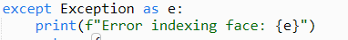

Alerts may also be used as a form of logging.

Figure 34. Code excerpt of a fetch method in client-side JavaScript code. It checks the response status of the triggered lambda function, and if there are issues, it will display it in an alert.

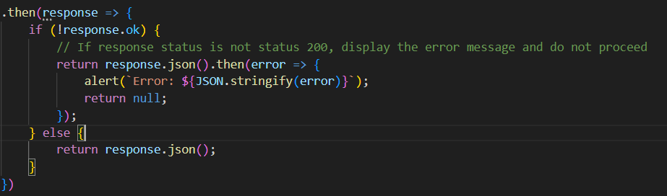

Figure 35. Another code excerpt of the same fetch method, which catches errors during the entire fetch process and shows it in an alert, which accounts for errors in the JavaScript code too.

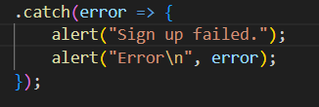

# Setup guide

Services Used and Their Roles

The web application uses these AWS services:

Amazon S3: Buckets used to store webpage files and host the static website, as well as store portraits of missing people respectively.

Amazon RDS: MySQL database used to store profile data of missing people.

Amazon Rekognition: Used for image analysis (face indexing, face detection, face comparison).

Amazon SNS: Used to send notifications to close contacts of missing people whose faces match faces detected in a scene image, up to the discretion of the user who submitted the scene image.

Amazon Cognito: Used for authentication.

AWS Lambda: Functions are used as server-side scripts for database operations, image analysis, messaging, and authentication.

Amazon API Gateway: HTTP API routes defined to connect client-side JavaScript code with server-side lambda functions for website functionality.

Interactions

Besides storing the webpage files in the “find-missing-faces-website” bucket, Amazon S3 has another bucket “find-missing-faces-portraits” that stores portraits of missing people for face indexing and display. The S3 key of the saved image is sent to Amazon Rekognition to index the face in the portrait, and the S3 URL is sent to the Amazon RDS MySQL database for storage as the profile’s portrait.

Amazon API Gateway interacts with AWS Lambda by triggering lambda functions using the website’s HTTP API routes listed below:

|  |  |  |
| --- | --- | --- |
| API Gateway Route | Triggered Lambda Function | Usage |
| /authentication (POST) | lambda-findmissingfaces-authentication | Authentication functions (Sign up, Sign in, Sign out, Verify email, Resend verification code) |
| /analyse-image (POST) | lambda-findmissingfaces-imageanalysis | Image analysis of scene images to detect faces in the image and attempt to match them to missing people in the database using facial comparison. |
| /notify-contact (POST) | lambda-findmissingfaces-sendmessage | Notify close contact via SMS that their missing person’s face matched a face in a scene image submitted. |
| /profiles/all (GET) | lambda-findmissingfaces-mysql | Retrieve data of all profiles from the database. |
| /profiles/{person_id} (GET) | Retrieve data of a specific profile with matching person_id as stated in {person_id}. |
| /profiles/add (POST) | Add a missing person to the database. |
| /profiles/update (PUT) | Update a missing person’s profile in the database. |
| /profiles/delete (DELETE) | Delete a missing person’s profile from the database. |

AWS Lambda interacts with all other services mentioned in “Services Used and Their Roles” through lambda functions utilising actions and operations from the services for website functionality.

This is a table the website’s lambda functions and the services AWS Lambda interacts with in them:

|  |  |
| --- | --- |
| Lambda Function | Service(s) Interacted With |
| lambda-findmissingfaces-createcollection | Amazon Rekognition.   * Creates a Rekognition collection to store indexed faces. * Operations used:  1. CreateCollection |
| lambda-findmissingfaces-authentication | Amazon Cognito.   * Uses Cognito actions for authentication functions. * Actions used:  1. ListUsers (Check for existing users with same email when a new user signs up) 2. SignUp 3. ConfirmSignUp (Email verification) 4. InitiateAuth (Sign in) 5. ResendConfirmationCode 6. GlobalSignOut |
| lambda-findmissingfaces-imageanalysis | Amazon Rekognition.   * Uses Amazon Rekognition’s API’s operations for image analysis. * Operations used:  1. DetectFaces 2. SearchFacesByImage   Amazon RDS   * Queries database for profile details of matched missing people based on their face ID. |
| lambda-findmissingfaces-sendmessage | Amazon SNS   * Uses SNS Actions to send an SMS message to the matching missing person’s close contact. * Actions used:  1. Publish |
| lambda-findmissingfaces-mysql | Amazon RDS   * Conducts database operations on the Amazon RDS MySQL database.   Amazon S3   * Saves a new portrait to S3, returning S3 URL to store in the database. * Delete old/invalid portraits submitted during profile update or addition. * Amazon S3 also interacts with Amazon Rekognition by sending S3 key for the portrait stored to have its face indexed. * Operations used:  1. PutObject 2. DeleteObject   Amazon Rekognition.   * Uses Amazon Rekognition’s API’s operations for face indexing to retrieve and store face IDs in the database. * Operations used:  1. SearchFacesByImage (To check if submitted portrait is a duplicate) 2. IndexFaces 3. DeleteFaces   Amazon SNS   * Uses SNS Actions to create a topic for a newly added missing person, returning the topic ARN to be stored in the database. * Subscribes a new contact. * Unsubscribes an obsolete contact. * Actions used:  1. ListTopics (To check if generated topic name is unique) 2. CreateTopic 3. Subscribe 4. ListSubscriptionsByTopic (To find subscription ARN of obsolete contact. Required to unsubscribe the contact) 5. Unsubscribe 6. DeleteTopic |

Figure 36. A visual overview of interactions for Find Missing Faces

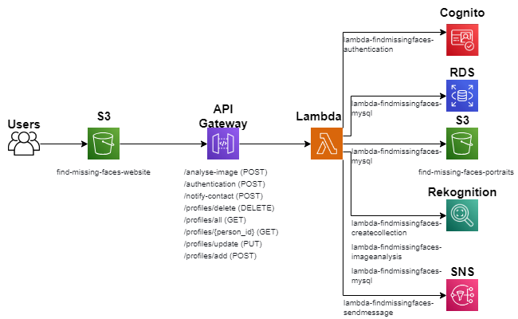

Amazon S3 Configuration Guide

The configuration for the S3 bucket “find-missing-faces-website” storing webpage files and hosting the static website has already been covered at “Website Set-Up on S3” under “Deployment Process”.

This configuration guide will cover the set up for the S3 bucket “find-missing-faces-portraits” which stores portraits of missing people:

1. **Create a bucket.**

1. Follow the steps stated in **Step 1. Create website S3 bucket** at “Website Set-Up on S3” under “Deployment Process”.

1. **Make portraits publicly accessible.**

Though not occurring during bucket set-up, this step is vital in ensuring that portraits of missing people profiles will be visible on the website.

1. When using the PutObject operation, specify ACL as “public-read” to allow the public to read (view) the portrait when it is displayed.

Figure 37. Code excerpt showing usage of the PutObject operation.



Amazon Relational Database Service (RDS) Configuration Guide

The MySQL database for Find Missing Faces is set up using the following steps once logged in to the AWS Management Console and once MySQL and MySQL workbench are installed [8]:

1. Go to Amazon RDS on AWS Management Console.
2. At Dashboard, scroll down and slick on the “Create database” button.
3. At the “Create Database” page, follow these configurations:
4. **Choose a database creation method**
   1. Select “Standard create”.

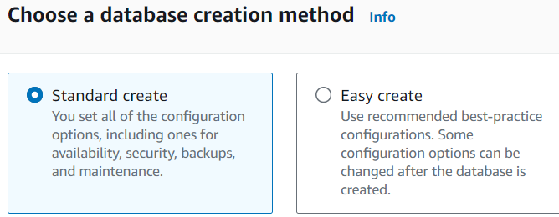

1. **Engine options**
   1. Select “MySQL” for “Engine type” since a MySQL database is to be used.

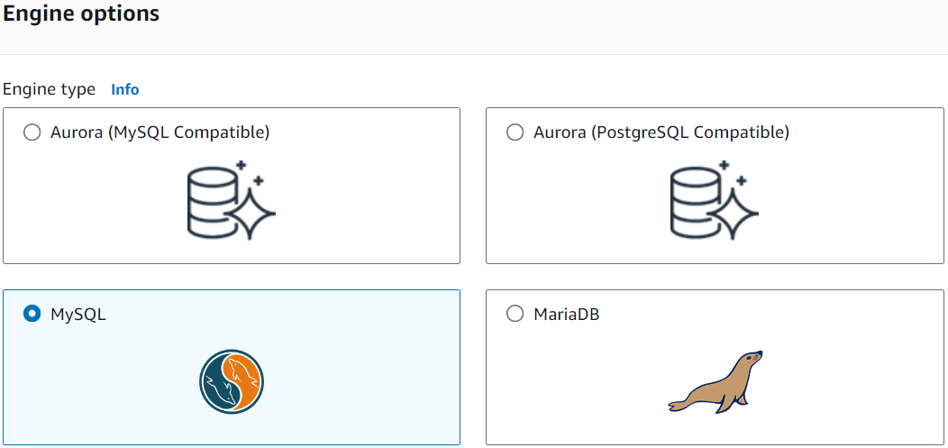

* 1. Make sure “MySQL Community” edition is clicked because that it what is used for Find Missing Faces.
  2. Under “Engine version”:
     1. Check that the Engine Version selected is the latest one.
     2. Uncheck “Enable RDS Extended Support” to not incur additional costs.

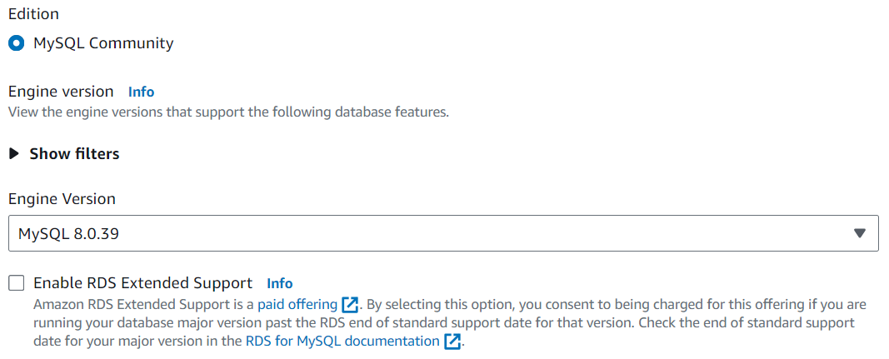

3

2

1

1. **Templates**
   1. Select “Free Tier” to incur less costs when experimenting with the database for Find Missing Faces.



1. **Settings**
   1. Enter a name for the database under “DB instance identifier”. The database used for Find Missing Faces was named “findmissingfacesprofiles”.

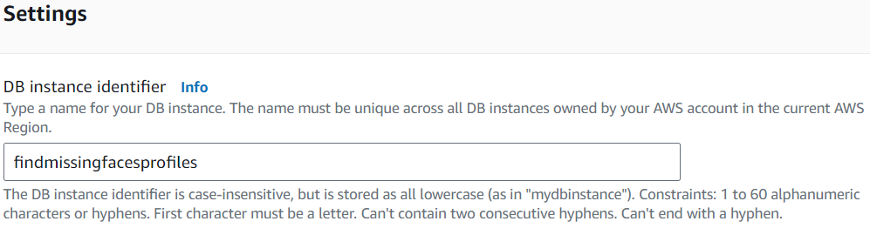

* 1. Under “Credentials Settings”:
     1. At “Master username”, enter the database master username; the username used when logging in to the database. The one used for Find Missing Faces is “admin”.
     2. Select “Self managed” under “Credentials management”. This means that you manually handle credentials for connecting to the database, which should be defined in lambda functions using database connections.
     3. Skip “Auto generate password” to use your own password.
     4. Under “Master password”, enter the password to connect to the MySQL database.
     5. Re-enter the password under “Confirm master password” to confirm it.

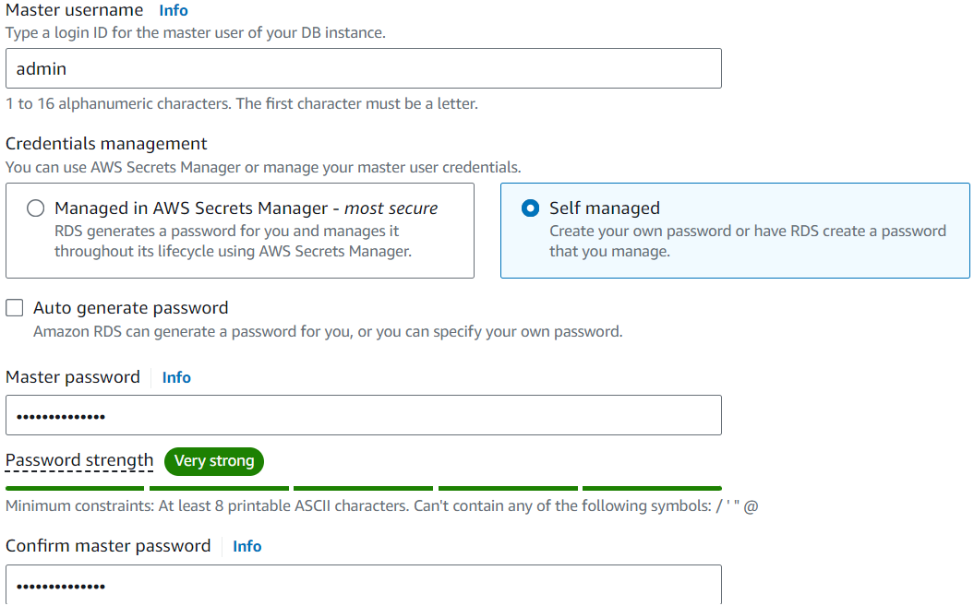

4

3

2

1

1. **Instance configuration**
   1. Leave as default.
2. **Storage**
   1. Leave all the settings as their default values.
3. **Connectivity**
   1. Check “Don’t connect to an EC2 compute resource” for “Compute resource” 3because the website does not use Amazon EC2.
   2. Check “IPv4” for “Network type” for simplicity.
   3. Leave “Virtual private cloud (VPC)” and “DB subnet group” as default.

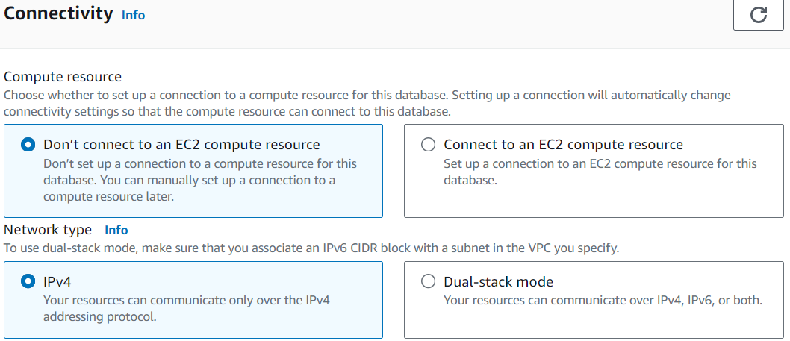

2

1

* 1. Check “Yes” for “Public access” so that the lambda function can interact with the database for website functionality.
  2. Under “VPC security group”, select “Create new” to create a security group allowing lambda to connect to the database.
  3. Under “New VPC security group name”, enter a name. The name used for Find Missing Faces is “find-missing-faces-group”.

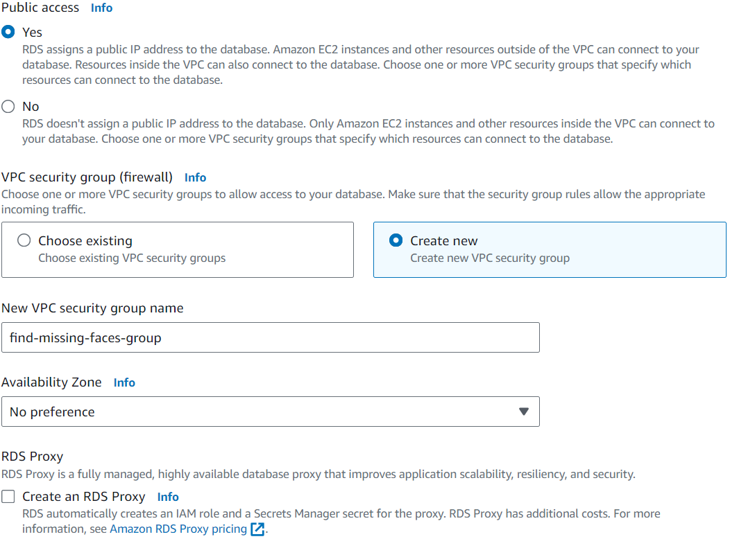

3

2

1

* 1. Leave “Availability Zone”, “RDS Proxy” and “Certificate authority” as default.
  2. At “Additional configuration”, ensure “Database port” is the same as for the connection created in MySQL.

Figure 39. Port specified as Database port for Additional configuration.

Figure 38. Port specified when creating the connection to the database in MySQL Workbench.

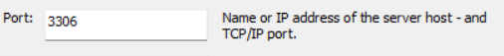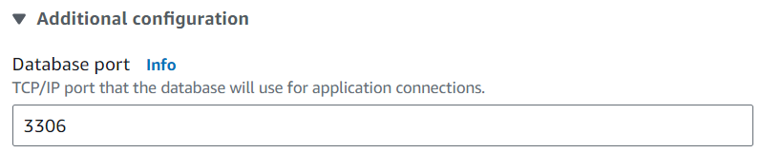

1. **Tags**
   1. No tags needed for Find Missing Faces.
2. **Database authentication**
   1. Select “Password authentication” under “Database authentication” to use the password defined earlier at “Settings”.

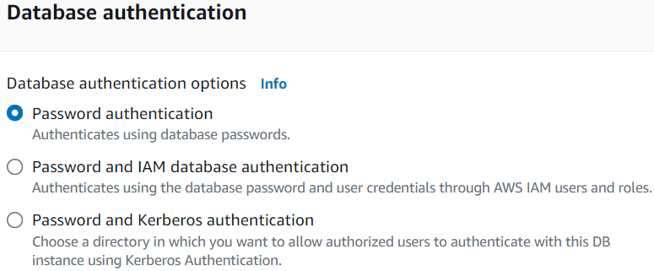

1. **Monitoring**
   1. Uncheck “Enable Enhanced Monitoring” as it is unnecessary.

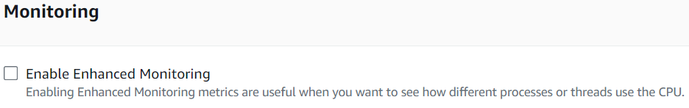

1. **Additional configuration**
   1. Leave as default.
2. Click on the “Create database” button at the bottom.
3. On the database details page at “Connectivity & security”, click the VPC security group link under “Security” to access the database’s security rules.

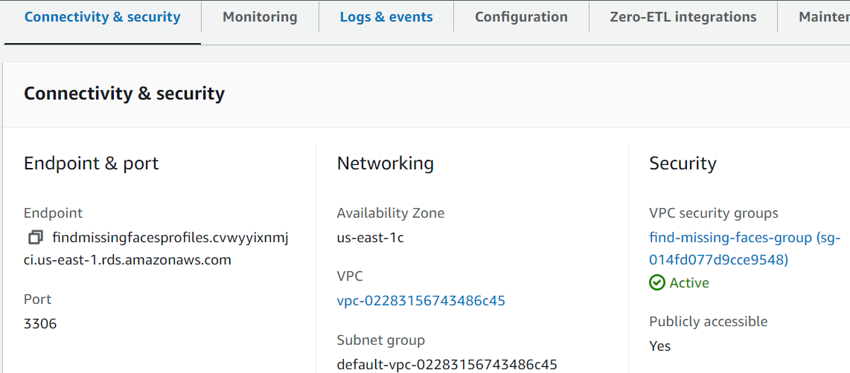

Click this

1. At the “Security Groups” page, click on the Security group ID.

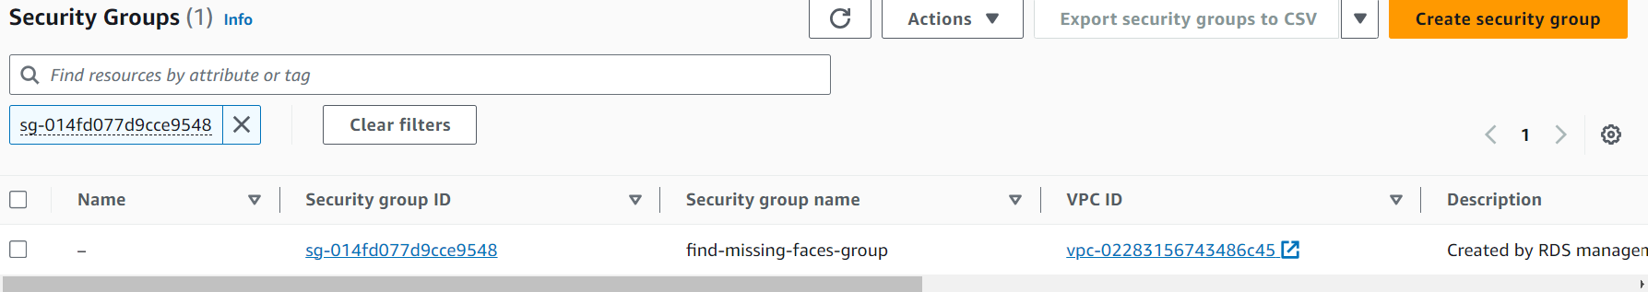

Click this

1. Once at the page for the security group, scroll down to “Inbound rules” and click the “Edit inbound rules” button.
2. At “Edit inbound rules”, change “Source” to “0.0.0.0/0” to make the database accessible to the public.

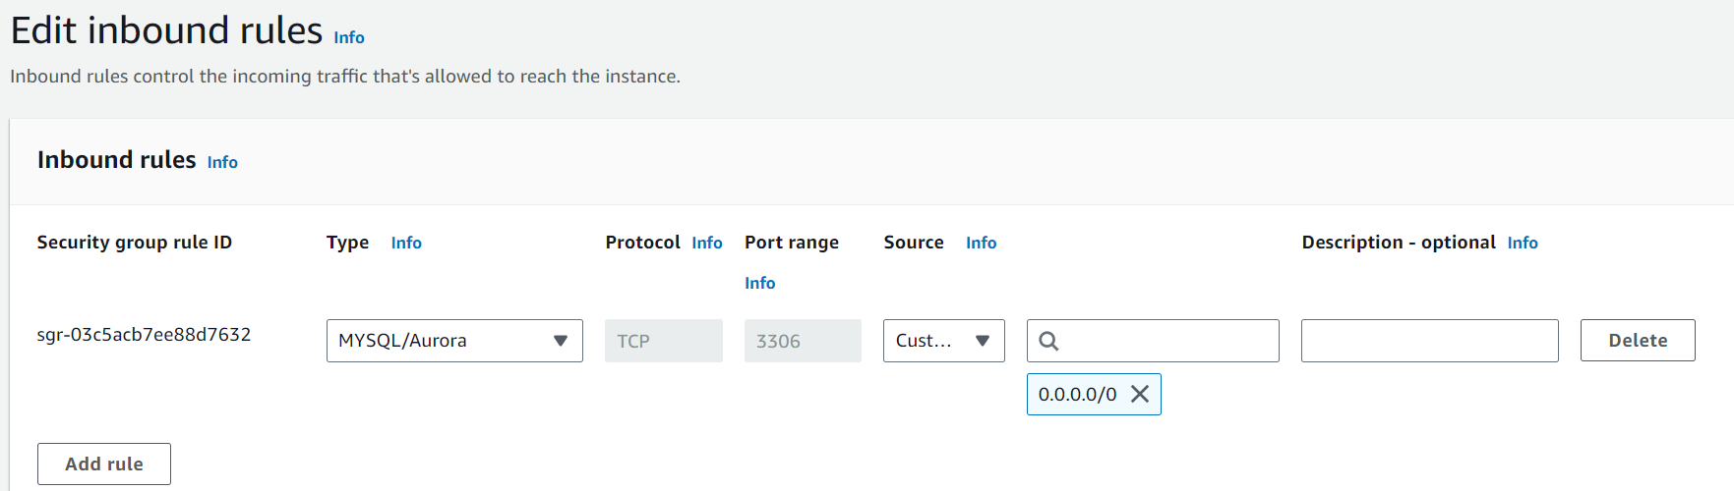

1. Click the “Save rules” button.
2. Create a connection in MySQL.
   1. Open MySQL workbench.
   2. Click on the plus icon next to “MySQL Connections” to create a new connection.
   3. At “Connection Name”, name the connection. For Find Missing Faces, the connection’s name is “Find Missing Faces – RDS MySQL”.
   4. Leave “Connection Method” as “Standard (TCP/IP)”.
   5. Under “Parameters”:
      1. Set “Hostname” as the database endpoint specified in Amazon RDS.
      2. Ensure the port is the same as the one specified in “Connectivity” at Step 3.
      3. Set “Username” as the Master username specified in “Settings”, “Credential Settings” at Step 3.
      4. Click on “Store in Vault” and enter the password specified in in “Settings”, “Credential Settings” at Step 3.
      5. Click on the “Test Connection” button.

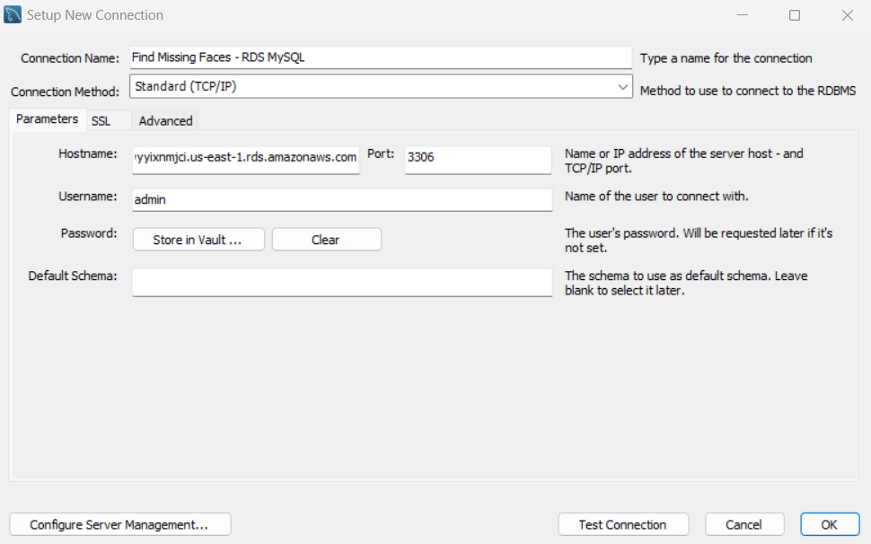

5

4

6

2222

1

3

* + 1. The connection should be successful as shown below.

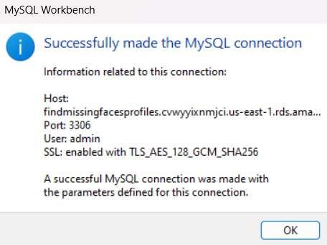

* + 1. Click on the created connection in the workbench.

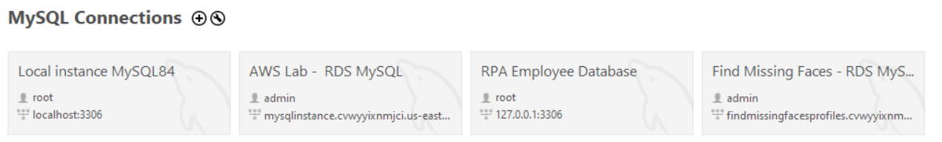

Click this

* + 1. Create a new schema (for this website, it is named “FindMissingPersons”) and new table (“missing_person”) to store data.

Amazon Simple Notification Service (SNS) Configuration Guide

Amazon SNS set-up for Find Missing Faces has been mentioned in Development of Amazon Simple Notification Service (SNS).

Besides specifying a mobile number as a sandbox destination phone number, there is no other set-up required because Find Missing Faces creates a topic and subscribes a contact to it based on when a missing person’s profile is created. The creation of a topic for a missing person and subscribing their close contact to it, sending messages and other usages are completed in lambda functions. Development of Amazon Simple Notification Service (SNS) contains details for topic creation and subscription, which are the typical set-up operations.

Amazon Rekognition Configuration Guide

Since Amazon APIs to a pre-built model for facial analysis is used, there is little set-up required except for creating a collection to store indexed faces. Configurations for the model’s usage is specified as arguments for the APIs’ operations. These have already been specified in Development of AWS Rekognition.

Amazon Cognito Configuration Guide

A user pool is created to store all users for Find Missing Faces, and to enable authentication.

The user pool is set up using the following steps once logged in to the AWS Management Console [4]:

1. Go to Amazon Cognito on AWS Management Console.
2. Click on the “Create user pool” button.
3. Under “Authentication providers”, select “Cognito user pool” at “Provider types” so that users sign in directly with their email address or username and password.
4. Under “Cognito user pool sign-in options”, check “User name” and “Email”.
5. Under “User name requirements”, check “allow users to sign in with a preferred user name” and “Make user name case sensitive” so that duplicate usernames are prevented even if in different case.

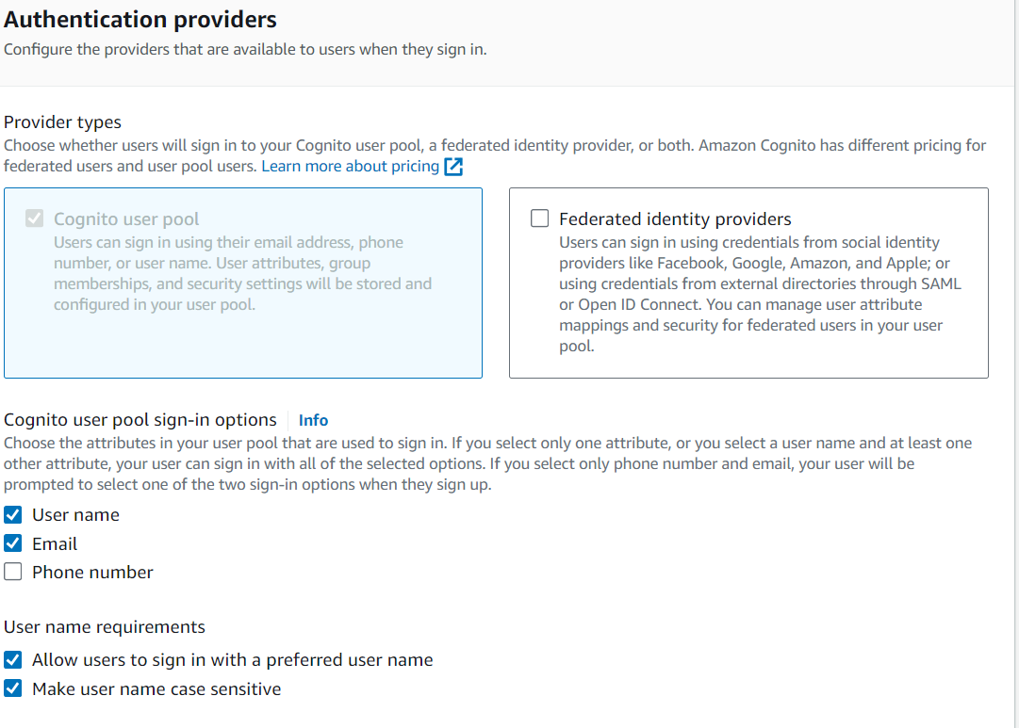

3

2

1

1. Click on the “Next” button.
2. Select “Custom” for “Password policy”.
3. Set “Password minimum length” to 12 characters.
4. Check everything in “Password requirements” to ensure that users use secure passwords.
5. Leave “Temporary passwords set by administrators expire in” as default since they are not used for Find Missing Faces.

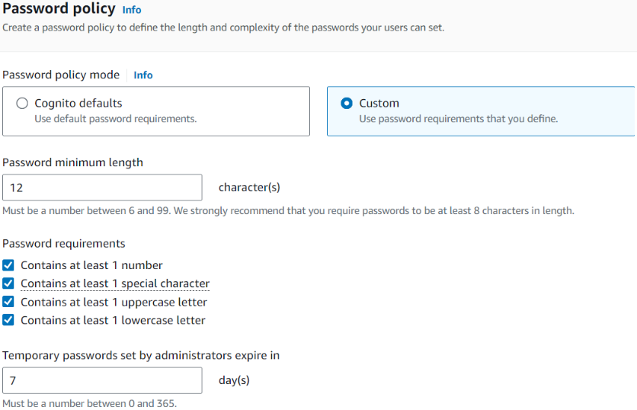

1

2

3

1. Under “Multi-factor authentication” and “MFA enforcement”, select “No MFA” to simplify the authentication process for users.

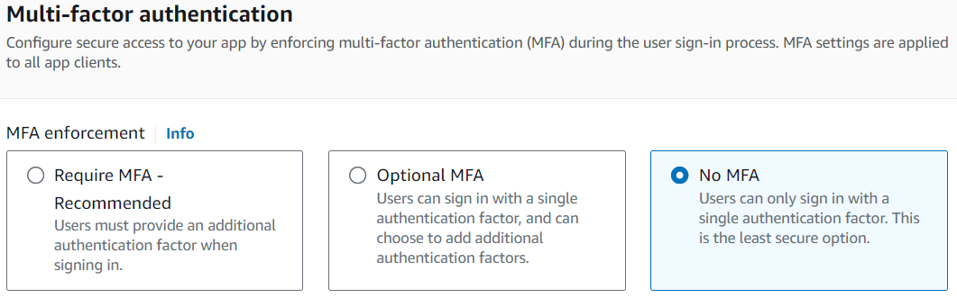

1. Leave “User account recovery” settings as default. It is not used in Find Missing Faces.
2. Click on the “Next” button.
3. Under “Self-service sign-up”, check “Enable self-registration” so that users can register accounts on their own, since Find Missing Faces relies on public contribution and thus should be more open.

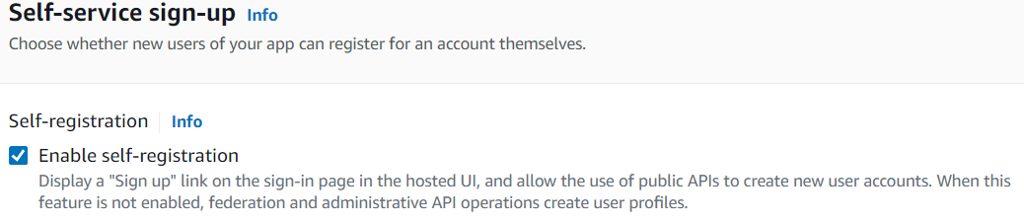

1. At “Attribute verification and user account confirmation”, under “Cognito-assisted verification and confirmation”, select “Allow Cognito to automatically send messages to verify and confirm” so that Cognito will automatically send verification codes to registering users.
2. Under “Attributes to verify”, check “Send email message, verify email address” for users to verify their email addresses via email since that is what they used to sign up.

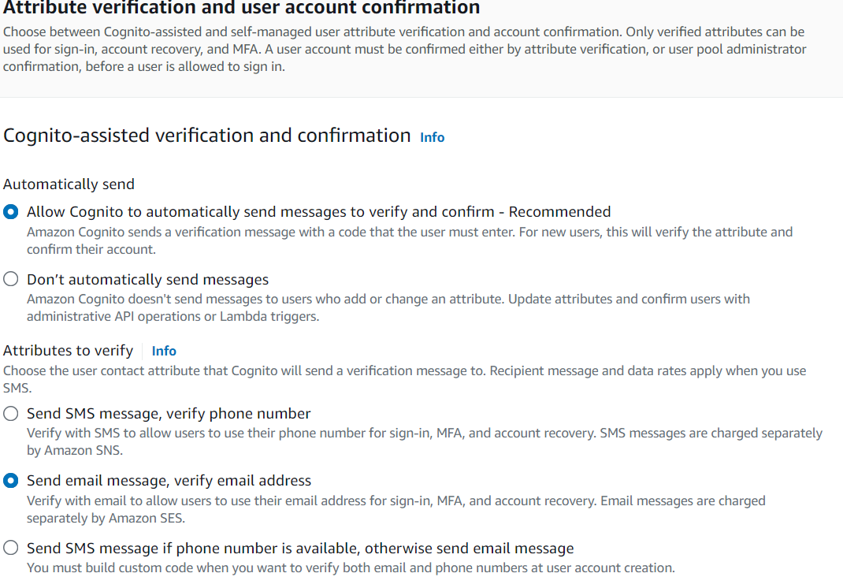

2

1

1. Under “Verifying attribute changes”, keep the settings as default since changing credentials is not implemented in Find Missing Faces.
2. Leave “email” as the sole required attribute under “Required attributes” as users only sign in with their username or email.

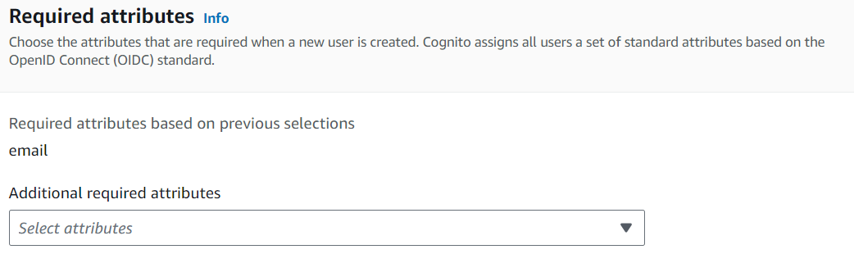

Leave this blank

1. Do not add custom attributes at “Custom attributes” as they are unnecessary. Simple authentication is sufficient for the website.
2. Click on the “Next” button.
3. Under “Email” and “Email provider”, select “Send email with Cognito” to use Cognito’s email address for email verification. This is used in lieu of Amazon SES as I have no access due to Learner Lab restrictions.

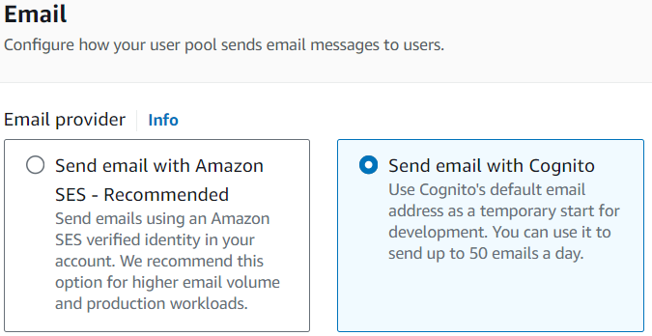

1. Click on the “Next” button.
2. Under “User pool name”, enter the user pool’s name. The name for Find Missing Face’s user pool is “FindMissingFaces-Authentication”.

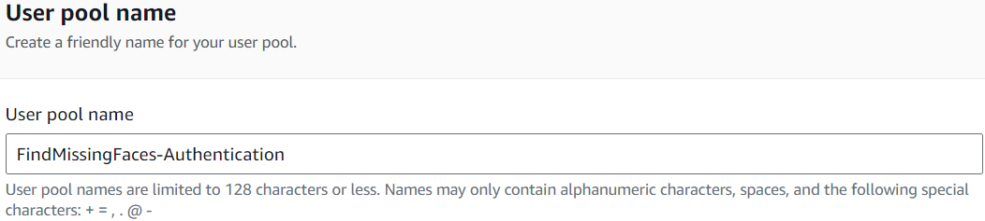

1. Leave “Use the Cognito Hosted UI” unchecked under “Hosted authentication pages”. Custom authentication pages have been coded out as Cognito Hosted UI requires the website to use HTTPS protocol, but Find Missing Faces hosted on S3 uses HTTP.

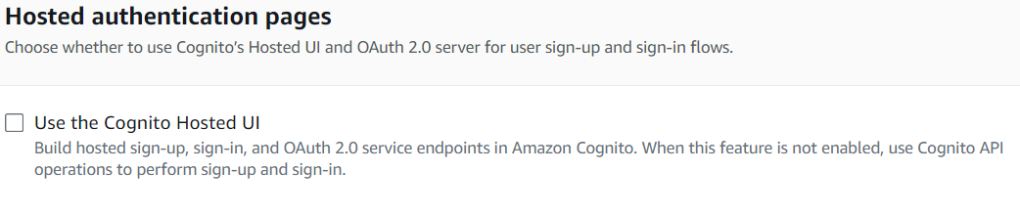

1. Select “Public client” for “App type” under “Initial app client”.
2. Enter a name for “App client name”. The name used for Find Missing Faces is “FindMissingFaces”.

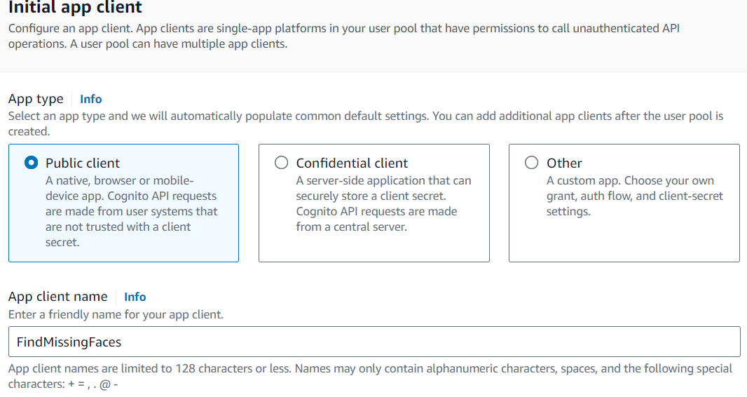

1

2

1. Leave “Client secret” as default value as it is not used.
2. Under “Advanced app client settings”
   1. For “Authentication flows”, select “ALLOW_REFRESH_TOKEN_AUTH”, “ALLOW_USER_SRP_AUTH” AND “ALLOW_USER_PASSWORD_AUTH” so that users can authenticate using refresh tokens, username, and password.
   2. Set “Authentication flow session duration” to 3 minutes.
   3. Set “Refresh token expiration” as 30 days.
   4. Set “Access token expiration” to 120 minutes (2 hours).
   5. Set “ID token expiration” to 120 minutes (2 hours).
   6. Leave “Advanced security configurations” as default.

The reasons behind these configurations are specified in Development of Amazon Cognito “Custom Configurations”.

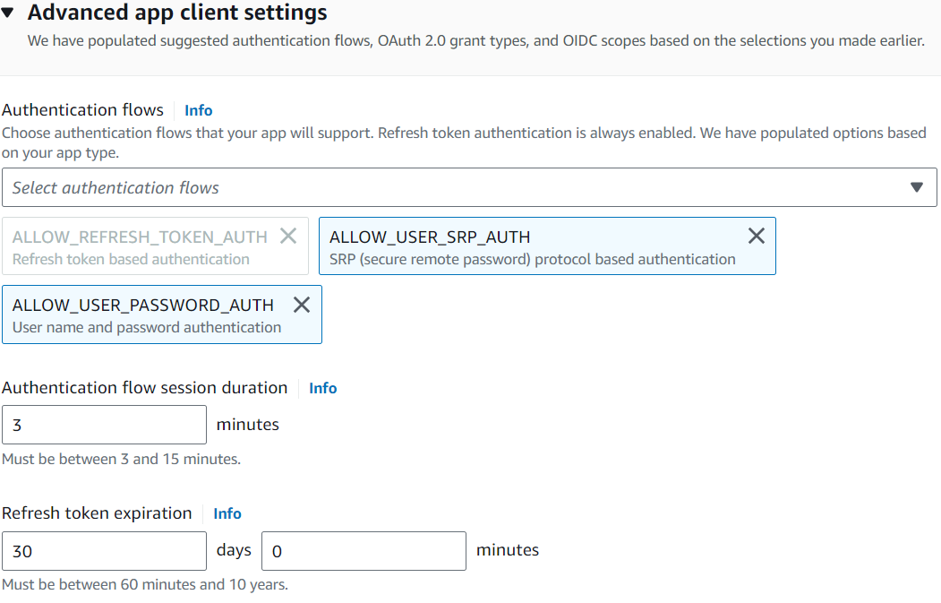 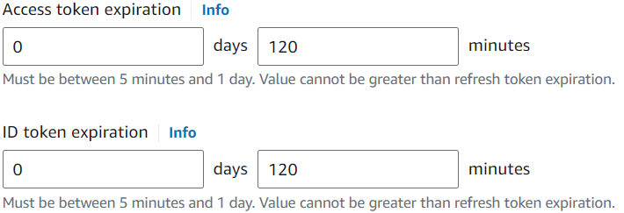

5

4

3

2

1

1. Leave “Attribute read and write permissions” as default.
2. Do not add anything in “Tags” since they are not needed.
3. Click on the “Next” button.
4. Look through the settings configured which are displayed to you.
5. If they are correct, proceed to click the “Create user pool” button.

AWS Lambda Configuration Guide

This guide shows how to configure one lambda function. Every lambda function mentioned at “Interactions” above uses the same set-up.

Each lambda function is set up using the following steps once logged in to the AWS Management Console [9]:

1. Go to AWS Lambda on AWS Management Console.
2. Click on the “Create function” button.
3. Select “Author from scratch”.
4. Under Basic Information:
5. Enter a function name at “Function name”.
6. Choose “Python 3.12” under “Runtime” as Python is used to write the lambda code.
7. Leave “Architecture” as default.
8. Under “Change default execution role”, check “Use an existing role”.
9. Select “LabRole” under “Existing role” as the Learner Lab account for AWS is used for this project.
10. Leave Advanced settings as default.

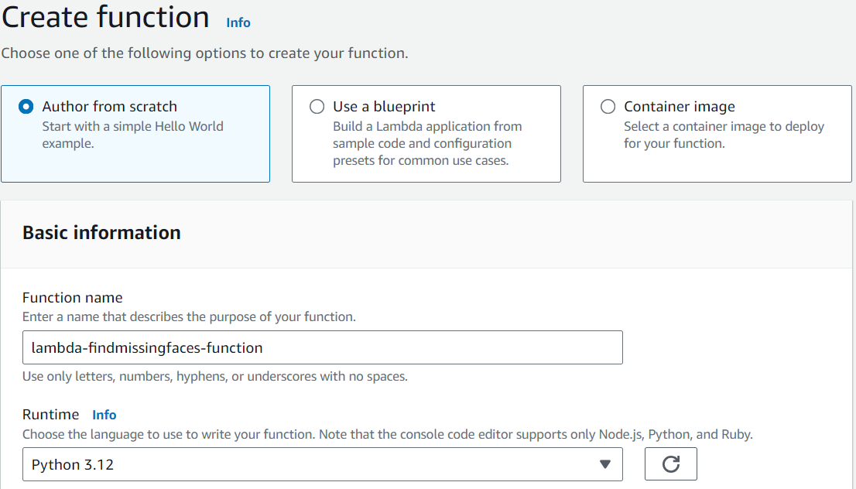

3

2

1

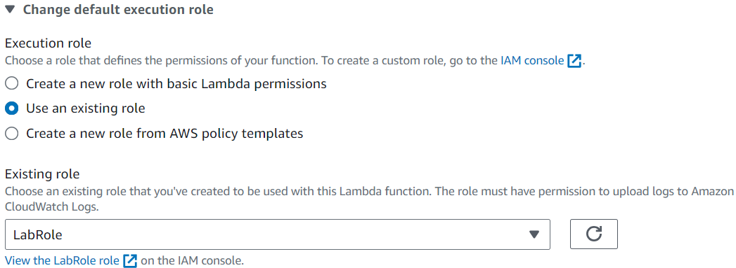

5

4

1. Click on the “Create function” button.

In addition to creating the function, necessary libraries must be imported into the function code.

In all lambda functions used for Find Missing Faces, boto3 is imported to use the Amazon SDK for Python to interact with AWS services. The services used are also be defined as clients in each lambda function before using their methods. [9]

Figure 40. Code excerpt of a lambda function showing how boto3 is imported, and how clients are initialised in functions using boto3.

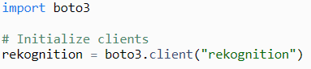

For lambda-findmissingfaces-mysql, PyMySQL is required as well for the Python code in the lambda function to interact with the Amazon RDS MySQL database. However, AWS Lambda’s runtime environment for Python does not include PyMySQL. As such, a layer for lambda-findmissingfaces-mysql must be created to import and use the PyMySQL library.

Here are steps to create and attach a layer containing the PyMySQL library to a lambda function [9]:

1. Prepare the PyMySQL library in .zip file.
   1. Google Colab is used in this case, with the following codes:

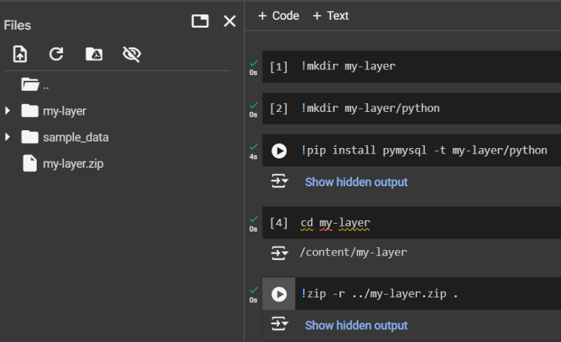

1. Return to AWS Lambda on the AWS Management Console.
2. Open the sidebar and click on “Layers”, under “Additional resources”.
3. At the “Layers” page, click on the “Create Layer” button.
4. At “Layer configuration”:
   1. Assign a name. The name entered under “Name” is “pymysql” in this vase.
   2. Skip “Description” since it is unnecessary.
   3. Check “Upload a .zip file”.
   4. Click on the “Upload” button to upload the zipped PyMySQL library from Step 1.
   5. Skip “Compatible architectures”.
   6. Skip “Compatible runtimes”.
   7. Skip “License”.

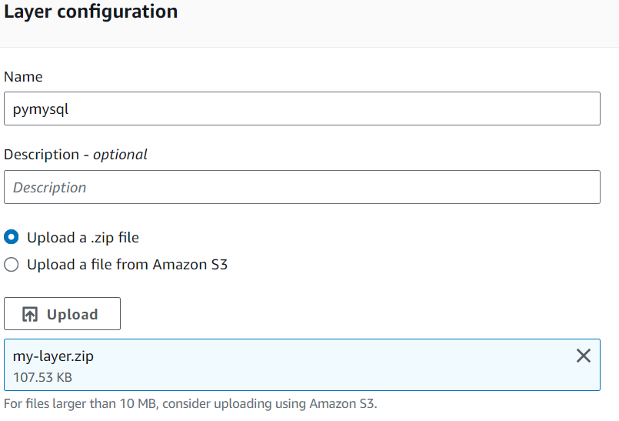

Zipped PyMySQL library uploaded.

3

2

1

1. Click the “Create” button to create the layer.
2. Once the layer has been created, you will be redirected to a page of its details.
3. Copy the ARN under “Version ARN”.

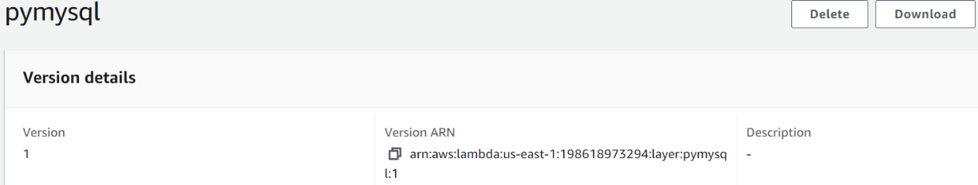

1. Open the sidebar.
2. Click on “Functions”.
3. Select the function which needs the PyMySQL library, in this case lambda-findmissingfaces-mysql.
4. At “Function overview”, click on Layers.

 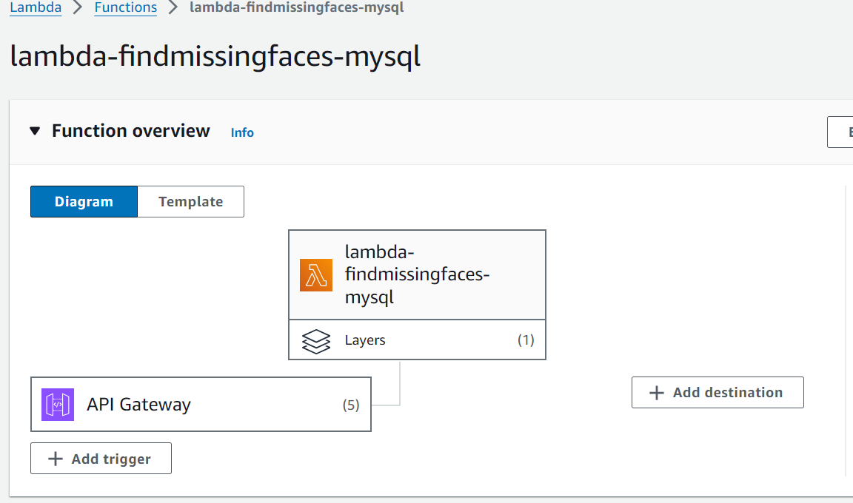

1. Scroll down to “Layers” and click on the “Add a layer” button.

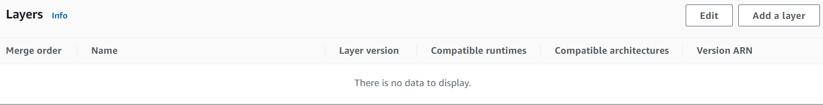

1. At “Add layer”, under “Choose a layer”, select “Specify an ARN”.
2. Paste the layer’s version ARN copied in Step 8.
3. Click on “Verify”.
4. If the output matches the configurations of the layer in 5ii, 5vi and 5v, proceed to click the “Add” button to add the layer to the function. Else, check that the version ARN you pasted belonged to the layer with the zipped PyMySQL library.

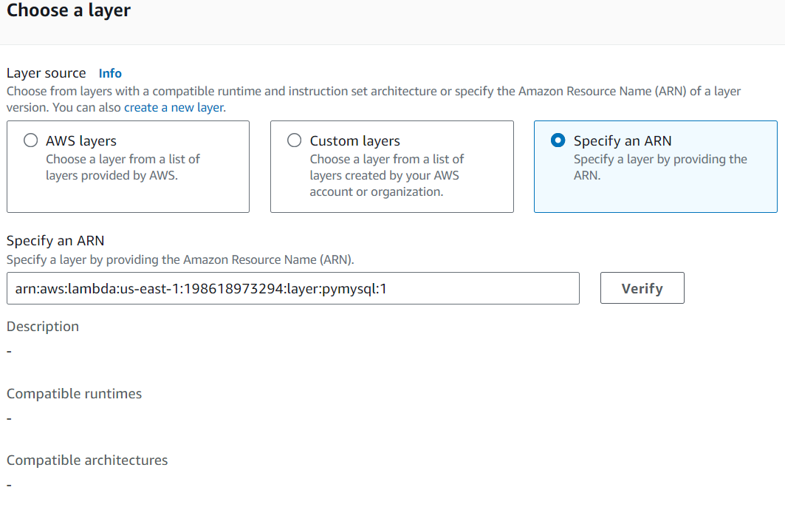

Output of verification.

3

2

1

1. In the details page for the function, which is lambda-findmissingfaces-mysql, there should be 1 layer displayed now.

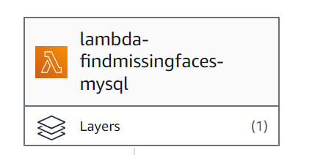

Amazon API Gateway Configuration Guide

Find Missing Face’s API from API Gateway is set up using the following steps once logged in to the AWS Management Console [10]:

1. Go to Amazon API Gateway on AWS Management Console.
2. Click the “Create API” button.
3. Select HTTP API by clicking on the “Build” button at the “HTTP API” section.

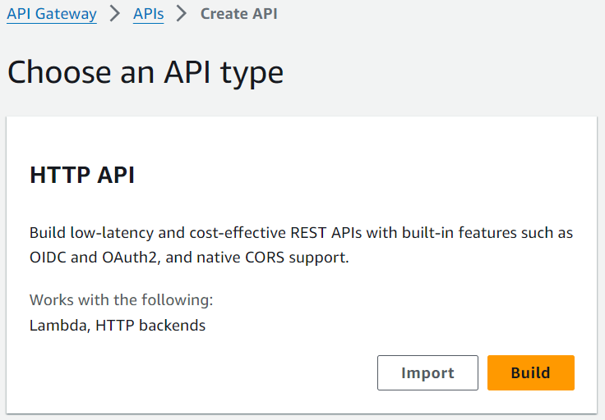

1. At “Create and configure integrations”, click on the “Add integration” button.
2. Click on the dropdown and select “Lambda”.
3. Under “Lambda function”, click on the input space and select the lambda function that should be triggered by the API.
4. Under “API name”, enter a name for the API. The API name for Find Missing Faces is “FindMissingFacesProfilesHTTPAPI”.

This example integrates lambda-findmissingfaces-mysql first, so lambda-findmissingfaces-mysql is chosen for “Lambda function”.

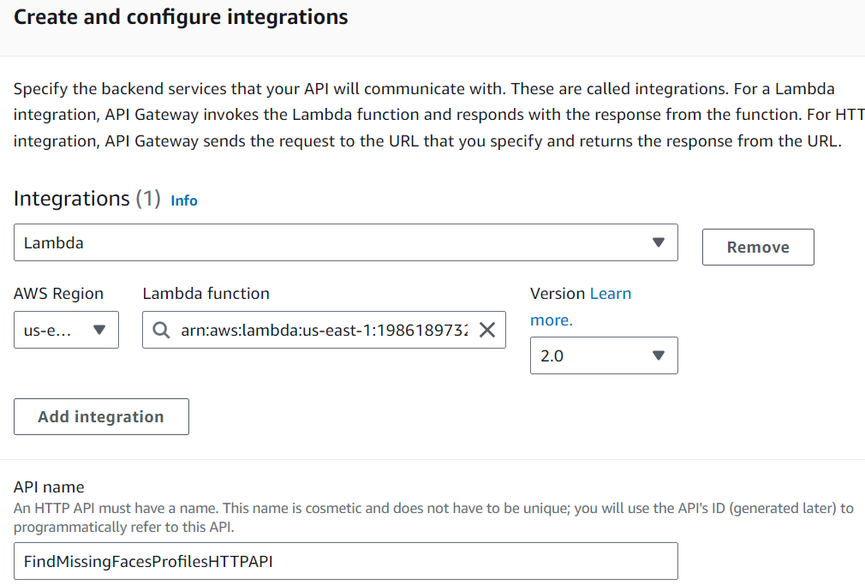

1. At “Configure routes”, configure the first route. Since lambda-findmissingfaces-mysql is integrated first, routes for database operations will be created. The first route is to get all profiles.
   1. Click on the dropdown beneath “Method” and select “GET”.
   2. Specify “Resource path” as “/profiles/all”.
   3. Select “lambda-findmissingfaces-mysql” as “Integration target”.
2. Click on the “Add route” button to add another route.
3. Repeat steps 8 and 9 until all routes for the database operations are created. The methods, resource paths and integration targets to set for all routes are shown below:

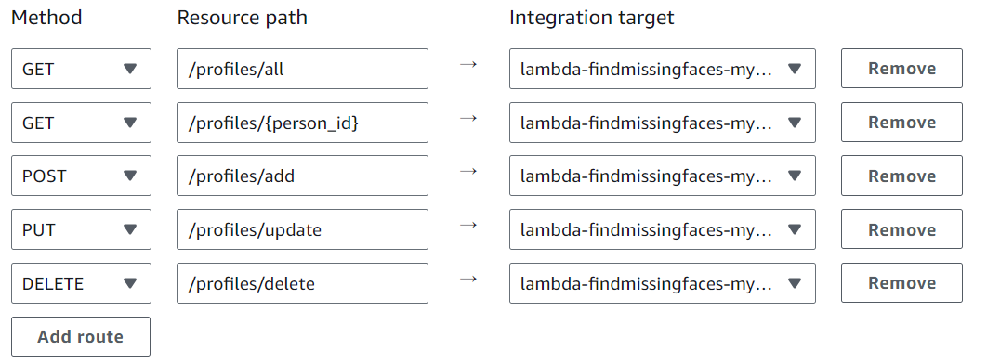

1. Click the “Next” button.
2. Under “Configure stages”, specify a different stage for the API to be deployed to. “Stage name” for Find Missing Faces is “findmissingfaces_test”.
3. Disable “Auto-deploy” to deploy the API manually whenever changes are configured.

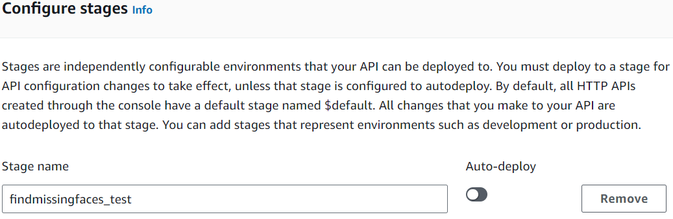

1. Click the “Next” button.
2. Review the configurations, then click the “Create” button.

The next steps will create API routes for other website functions, under the same API. This has to be done one-by-one.

1. Go back to “APIs” in API Gateway.
2. Click on the created API (FindMissingFacesProfilesHTTPAPI).
3. Under “Routes for FindMissingFacesProfilesHTTPAPI”, click the “Create button”.
4. Specify the route and method similarly as in Step 8. These are methods and routes for other functions in Find Missing Faces:

Figure 41. Method and route to trigger lambda-findmissingfaces-authentication.

Figure 42. Method and route to trigger

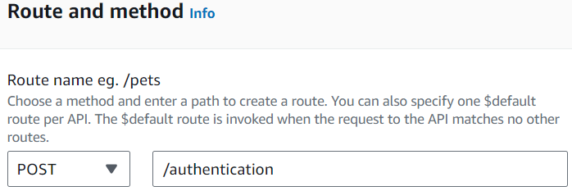 lambda-findmissingfaces-imagenanalysis.

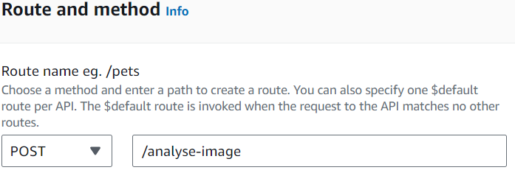

Figure 43. Method and route to trigger lambda-findmissingfaces-sendmessage.

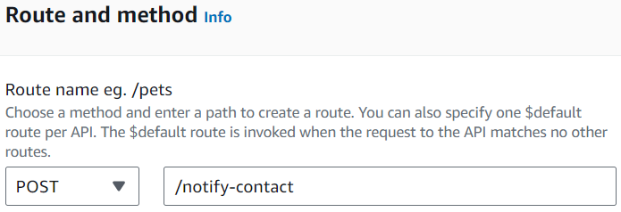

1. Click on the “Create” button.
2. Click on the newly created route under “Routes for FindMissingFacesProfilesHTTPAPI” to expand and reveal the method used in the route, then click on that method to see “Route details”.
3. Under “Integration” in “Route details”, click on the “Attach integration” button.

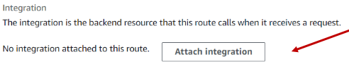 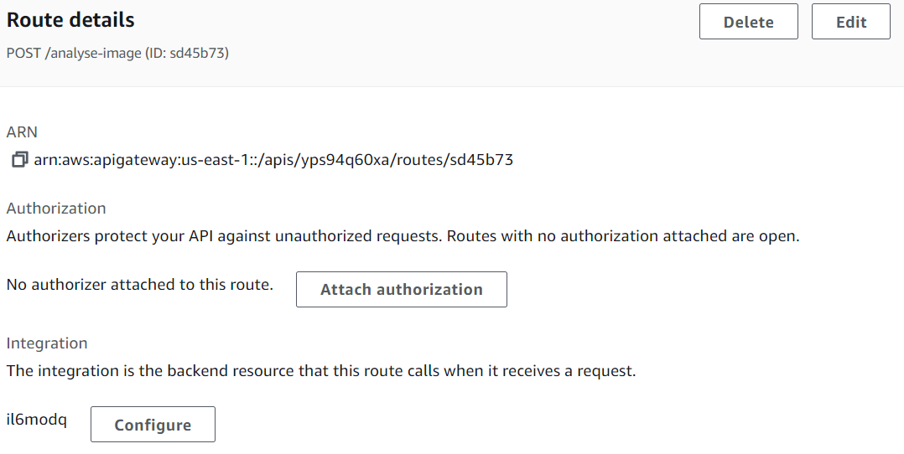

1. At “Integration details for route”, click on the “Choose an existing integration” dropdown and select the lambda function that should be triggered by this API route.

These are the integrations for the API routes of Find Missing Faces functions outside of database operations.

Figure 44. Selected lambda-findmissingfaces-imagenanalysis lambda function to integrate with /analyse-image route.



Figure 45. Selected lambda-findmissingfaces-authentication lambda function to integrate with /analyse-image route.



Figure 46. Selected lambda-findmissingfaces-sendmessage lambda function to integrate with /analyse-image route.



1. Click on the “Attach integration” button.
2. 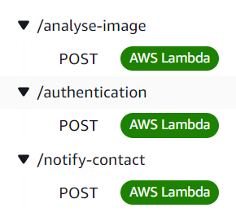You can confirm that the integration has been attached if “AWS Lambda” shows up next to the API route’s method under “Routes for FindMissingFacesProfilesHTTPAPI” as shown below.

Figure 47. API routes for remaining Find Missing Faces functions.

1. Repeat steps 16 to 24 using Figures 42 to 46 as configuration references to create API routes for the remaining non-database operations.
2. 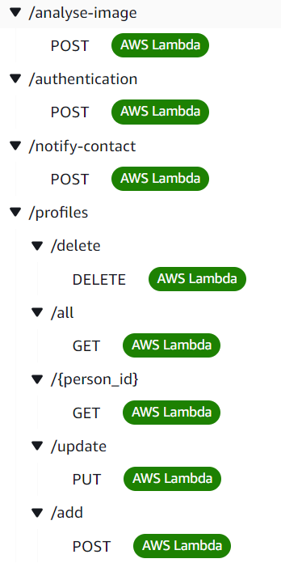You should have these routes at the end:
3. At Integrations, click on the “Deploy” button.

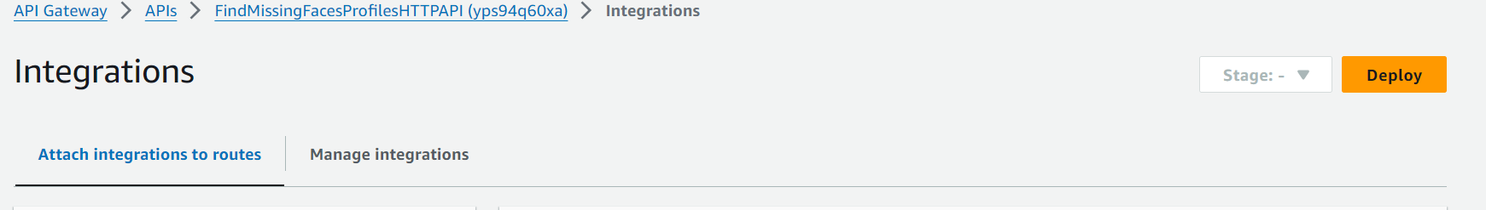

1. 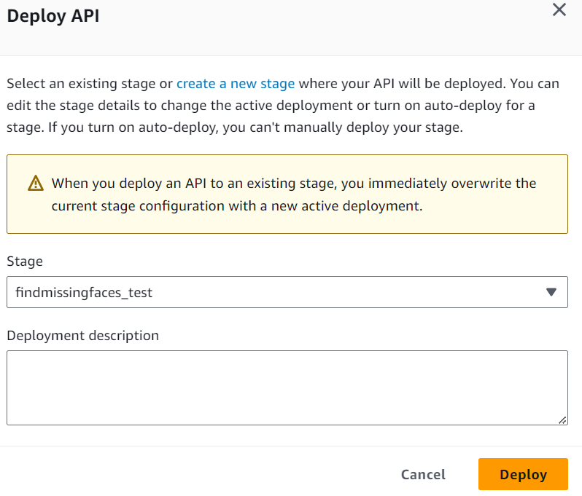Select the “findmissingface_test” stage in the dropdown and click the “Deploy” button to deploy all API routes.
2. Ensure that the CORS configuration for the routes is set according to what is specified under “CORS Issue” in page 28 and 29.

# Conclusion

Unfortunately, due to sudden updates in Learner Lab, access to originally proposed services that would have added far more value and interactivity (Amazon Lex, CloudSearch and CloudFront) were unable to be integrated into Find Missing Faces as Learner Lab no longer has access to use them.

Using these services in the future if access is provided would vastly improve the project, allowing users to receive more advice and background on how to fully utilise Find Missing Faces features, to more efficiently search profiles and offering them a better user experience using a content delivery network.

# References

1. <https://www.missingpeople.org.uk/for-professionals/policy-and-research/information-and-research/key-information>
2. <https://docs.aws.amazon.com/rekognition/latest/dg/what-is.html>
3. <https://docs.aws.amazon.com/sns/>
4. <https://docs.aws.amazon.com/cognito/?icmpid=docs_homepage_security>
5. <https://docs.aws.amazon.com/AmazonS3/latest/userguide/Welcome.html>
6. <https://docs.aws.amazon.com/apigateway/latest/developerguide/http-api-cors.html>
7. <https://docs.aws.amazon.com/apigatewayv2/latest/api-reference/apis-apiid.html#apis-apiid-model-cors>
8. <https://docs.aws.amazon.com/rds/>
9. <https://docs.aws.amazon.com/lambda/?icmpid=docs_homepage_featuredsvcs>
10. <https://docs.aws.amazon.com/apigateway/>